DIALOGUES WITH THE MASTER PART 1
INTERFAITH MINISTRY

STUDENT: MASTER, I HATE WORKING, BUT I MUST WORK TO LIVE. WHAT DO YOU SUGGEST?
MASTER: PICK A CAREER THAT YOU ENJOY, AND YOU WILL NEVER HAVE TO WORK.
STUDENT: MASTER, THERE IS SO MUCH UGLINESS IN THE WORLD. HOW CAN I DEAL WITH ALL OF THE UGLINESS AND HATE IN THIS WORLD WITHOUT LOSING MY MIND?
MASTER: EVERYTHING IS BEAUTIFUL, BUT MOST PEOPLE ARE BLIND TO MOST OF THE BEAUTY.
STUDENT: MASTER, I AM SO STUPID. I WISH I WERE SMART. HOW DO YOU MANAGE TO LEARN SO EFFECTIVELY? HOW DO YOU ABSORB SO MUCH INFORMATION AND ACQUIRE SO MANY SKILLS?
MASTER: I FORGET WHAT I HEAR. I REMEMBER WHAT I SEE. I LEARN WHAT I DO.
STUDENT: MASTER, FOR EVERY WISE MAN ON THIS EARTH, THERE ARE A THOUSAND FOOLS. HOW AM I TO LEARN, GIVEN THAT ONE CANNOT LEARN FROM FOOLS, ONLY FROM WISE MEN?
MASTER: IF I AM WITH TWO MEN, ONE MY INFERIOR, THE OTHER MY SUPERIOR, EACH IS MY TEACHER. FROM THE SUPERIOR, I LEARN WHAT I SHOULD DO. FROM THE INFERIOR, I LEARN WHAT I SHOULD NOT DO.
STUDENT: SO I SHOULD THINK OF FOOLS AS INVERTED WISE MEN---AS WISE MEN WITH A NEGATION SIGN IN FRONT OF THEM, SO TO SPEAK.
MASTER: CORRECT.
STUDENT: AND TO CONVERT A FOOL INTO A WISEMAN, I NEED ONLY MAKE THE NECESSARY INVERSIONS—I NEED ONLY NEGATE THE NEGATION SIGN, AS IT WERE.
MASTER: CORRECT.
STUDENT: MASTER, OTHERS ARE SO MUCH SMARTER AND FASTER THAN I AM. SURELY I AM NO MATCH FOR THESE PEOPLE, WITH THE QUICK WITS AND LIGHTNING FAST INTELLECTS.
MASTER: SLOW AND STEADY WINS THE RACE, MY SON. STUDENT: I HOPE YOU ARE RIGHT, MASTER.
MASTER: MY SON, IT DOES NOT MATTER HOW SLOWLY YOU GO. STUDENT: IT DOESN’T.

MASTER: NO, IT DOES NOT. JUST AS LONG AS YOU DO NOT STOP.
STUDENT: THAT MAKE SENSE. MASTER: YES.
STUDENT: MASTER, THERE ARE SO MANY GENIUSES IN THIS WORLD, SO MANY PEOPLE WHO, UNLIKE ME, WERE BORN WITH AN ABUNDANCE OF TALENT. HOW AM I TO COMPETE WITH SUCH PEOPLE?
MASTER: YOUR QUESTION IS MISCONCEIVED, MY SON. STUDENT: HOW SO, MASTER?
MASTER: MEN’S NATURES DIFFER LITTLE. IT IS THEIR HABITS THAT SEPARATE THEM.
STUDENT: SO IT ISN’T THAT I LACK ABILITY. MASTER: THAT’S RIGHT.
STUDENT: IT’S THAT I NEED TO USE MY CHARACTER TO DEVELOP SUCH ABILITY AS I HAVE.
MASTER: EXACTLY, MY SON. STUDENT: THANK YOU MASTER.

DIALOGUES WITH THE MASTER PART 2
MAX KHAN

STUDENT: MASTER, I HATE MY SCHOOL. I HATE MY CITY. I WANT TO TRANSFER TO ANOTHER UNIVERSITY AND MOVE TO ANOTHER CITY.
MASTER: MY SON, WHEREVER YOU GO, THERE YOU ARE. STUDENT: YOU MEAN, YOUR PROBLEMS TEND TO FOLLOW YOU? MASTER: YES.
STUDENT: MASTER, I AM SO DEPRESSED. I FAIL ALL THE TIME. FOR EVERY ONE TIME I SUCCEED, I HAVE TO FAIL TEN TIMES.
MASTER: MY SON, OUR GREATEST GLORY LIES NOT IN NEVER FALLING BUT IN GETTING UP AND GETTING BACK ON TRACK EVERY TIME WE DO.
STUDENT: BUT MY FAILURES ARE SO HUMILIATING. MY EGO CANNOT TAKE MUCH MORE.
MASTER: IT DOESN’T MATTER HOW OFTEN YOU FAIL. IT MATTERS HOW OFTEN YOU SUCCEED.
STUDENT: DO ALL SUCCESSFUL PEOPLE STUMBLE ON THEIR WAY TO SUCCESS. MASTER: ALL OF THEM. MANY TIMES. THEY ALL STUMBLE AND FALL. STUDENT: WHY IS THIS NOT GENERALLY KNOWN?
MASTER: BECAUSE WHAT MATTERS IS THEIR SUCCESSES, NOT THEIR FAILURES. STUDENT: AS YOU JUST SAID.
MASTER: AS I JUST SAID.
STUDENT: MASTER, I HAVE TO CHOOSE BETWEEN TWO MUTUALLY EXCLUSIVELY CAREER PATHS? WHAT SHOULD I DO?
MASTER: THAT I CANNOT SAY. WHAT I CAN SAY IS, WHATEVER YOU DO, DO IT ALL WITH YOUR HEART.
STUDENT: MASTER, THERE ARE SO MANY PEOPLE WHO HAVE ACCOMPLISHED NOTHING AND YET ARE FAMOUS, AND I HAVE ACCOMLISHED SO MUCH AND I AM A COMPLETE NOBODY.
MASTER: WORRY NOT THAT NOBODY KNOWS WHO YOU ARE. WORRY THAT YOU ARE NOT WORTH KNOWING.
STUDENT: MASTER, I HAVE ABILITIES. MANY ABILITIES. BUT WHAT ASSURANCE DO HAVE THAT MY ABILITIES WILL BE ECONOMICALLY USEFUL?
MASTER: ABILITY WILL NEVER CATCH WITH THE DEMAND FOR IT, MY SON.
STUDENT: MASTER, I HAVE SO MUCH ABILITY, AND YET I AM SO FAR FROM LIVING AS I WANT TO LIVE. I AM SO FAR FROM REACHING MY GOALS.
MASTER: ABILITY IS ONLY HALF THE BATTLE, MY SON. FULFILLMENT OF ONE’S

EXPECTATIONS DEPENDS ON DILLIGENCE. THE MECHANIC WHO WOULD PERFECT HIS CRAFT MUST FIRST SHARPEN HIS TOOLS.
STUDENT: ABILITY---EVEN GENIUS---IS NOT ENOUGH.
MASTER: WITHOUT DILLIGENCE, THERE IS RAW TALENT, BUT NO ABILITY, AND CERTAINLY NO GENIUS.
STUDENT: YOU MEAN, GENIUSES ARE MADE, NOT BORN. MASTER: EXACTLY.
STUDENT: MASTER, I HAVE GREAT ADMIRATION FOR YOU. BUT SOMETIMES I FEEL THAT YOU SHOULD LET YOUR GUARD DOWN. YOU ARE ALWAYS ON HIGH ALERT, AS IT WERE.
MASTER: THE SUPERIOR MAN, WHEN RESTING IN SAFETY, DOES NOT FORGET THAT DANGER MAY COME.
STUDENT: AND WHEN DANGER DOES COME, WHAT IS THE SUPERIOR MAN’S ATTITUDE? HOW IS IT DIFERENT FROM WHEN HIS SITUATION IS SECURE?
MASTER: MY SON, WHEN HE IS IN A STATE OF SECURITY, HE DOES NOT OVERLOOK THE POSSIBILITY OF RUIN. WHEN ALL IS ORDERLY, HE KNOWS THAT DISORDER MAY COME. AND SO IT IS THAT WHEN DISASTER STRIKES, HE IS READY. THEREFORE, HIS ATTITUDE, WHILE DULY REFLECTING CHANGING REALITIES, IS STABLE AND CENTERED.
STUDENT: THANK YOU MASTER.

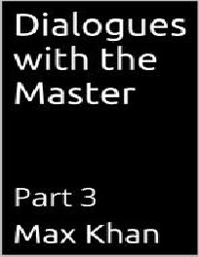

DIALOGUES WITH THE MASTER PART 3
MAX KHAN

STUDENT: MASTER, I AM SO ANGRY AT MY PROFESSOR. I AM SO ANGRY AT MY PARENTS. THERE ARE SO MANY PEOPLE WHO HAVE FAILED ME, AND I AM CONSUMED WITH HATRED FOR THEM.
MASTER: WHEN SOMEONE IS UNDER THE INFLUENCE OF ANGER, HIS CONDUCT IS MISGUIDED. TAKE A TIME-OUT AND REVISIT THE SITUATION FROM A CALMER VANTAGE.
STUDENT: WHAT IS THE ROLE OF ANGER IN STATECRAFT? SURELY IT SOMETIMES HAS A CONSTRUCTIVE FUNCTION.
MASTER: ALL I KNOW IS, IT WAS BY MUSIC THAT THE ANCIENT RULERS OF OUR GREAT LAND GAVE EXPRESSION TO THEIR JOY, AND IT WAS THROUGH SWORDS AND AXES THAT THEY GAVE EXPRESSION TO THEIR ANGER.
STUDENT: MASTER, I CAN THINK OF NOTHING EXCEPTING AVENGING THE WRONGS THAT HAVE BEEN DONE TO ME.
MASTER: TO BE WRONGED IS TRIVIAL, MY SON, UNLESS YOU INSIST ON PERPETUATING THE EXISTENCE OF THAT WRONG BY CONTINUING TO DWELL ON IT.
STUDENT: I AM NOT CONVINCED BY YOUR WORDS, MASTER. I OWE IT TO MYSELF TO CORRECT THE INJUSTICES THAT I HAVE EXPERIENCED.
MASTER: WHEN YOU ARE ABOUT TO ACT IN ANGER, THINK OF THE CONSEQUENCES.
STUDENT: PERHAPS YOU ARE RIGHT, MASTER. THERE IS MORE TO LIFE THAN DISCHARGING HATE.
MASTER: I AM RIGHT, MY SON. AND YES, THERE IS.
STUDENT: IS YOUR WISDOM BASED ON EXPERIENCE, OR ON THE PURE LIGHT OF YOUR INTELLECT?
MASTER: ALL WISDOM IS BASED ON EXPERIENCE. BITTER EXPERIENCE. AND LOTS OF IT.
STUDENT: THAT IS SO DARK.
MASTER: NO, THE EXPERIENCES WERE DARK. THE WISDOM THEREBY BEQUEATHED TO ME IS THE OPPOSITE OF DARK.
STUDENT: SO WISDOM IS ABOUT TURNING DARNESS INTO LIGHT. MASTER: YES.
STUDENT: MASTER, YOU ANSWER QUESTIONS, BUT YOU ARE VERY CAREFULY WITH YOUR WORDS. NOT EXACTLY RESERVED. BUT VERY JUDICIOUS ABOUT WHAT YOU SAY AND HOW YOU SAY IT.
MASTER: THE SUPERIOR MAN IS CAREFULY ABOUT WHAT HE SAYS AND HOW HE

SAYS IT. HE DOES NOT SPEAK LOOSELY.
STUDENT: AND WHENEVER THERE IS A PROBLEM IN YOUR LIFE, YOU ARE QUICK TO ADDRESS IT. YOU ARE NEVER IDLE.
MASTER: THE SUPERIOR MAN IS NEVER IDLE. HE PRACTICES WHAT HE PREACHES, AND HE EITHER RECONCILES HIMSELF TO HIS SITUATION OR HE CHANGES IT.
STUDENT: DO I HAVE IT IN ME TO BE THE MAN THAT YOU ARE, MASTER?
MASTER: IF YOU EARNESTLY TRY TO BE A SUPERIOR PERSON, YOU ARE, FOR THAT VERY REASON, ON YOUR WAY TO BEING SUCH A PERSON.
STUDENT: WHAT IF I DON’T HAVE THE WILL POWER TO DO THE RIGHT THING?
MASTER: IT IS NOT A QUESTION OF WILL POWER. IT IS A QUESTION OF COURAGE. MORAL COURAGE. TO KNOW WHAT YOU MUST DO AND STILL NOT DO IT SHOWS A LACK OF MORAL COURAGE.
STUDENT: AND THAT IS THE WORST SIN OF ALL? MASTER: IT IS.
STUDENT: THANK YOU, MASTER.

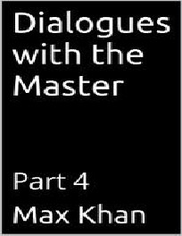

DIALOGUES WITH THE MASTER PART 4
MAX KHAN

STUDENT: MASTER, SO MANY PEOPLE HAVE WRONGED ME, AND ONLY A FEW HAVE BEEN GOOD TO ME.
MASTER: FORGET INJURIES. NEVER FORGET KINDNESS.
STUDENT: MASTER, WE LIVE IN SUCH A DARK WORLD. WHAT IS THE MEANING OF IT ALL?
MASTER: THE DARKNESS IS INSIDE OF YOU, MY SON, AND YOU ARE PROJECTING IT OUT ONTO THE WORLD?
STUDENT: YOU MEAN, THE WORLD ITSELF IS GREAT?
MASTER: YES, THERE ARE NO WORDS TO DESCRIBE ITS GREATNESS. STUDENT: AND MY SOURNESS IS BLINDING ME TO ITS GREATNESS? MASTER: YES, AND THUS PREVENTING YOU FROM LIVING FULLY.
STUDENT: SO ONE CANNOT LIVE FULLY IF ONE DOES NOT SEE THE WORLD’S BEAUTY.
MASTER: THAT’S RIGHT.
STUDENT: BUT SO FEW PEOPLE ARE HONEST, AND THERE IS SO MUCH TO BE GAINED BY LYING. THERE IS SO MUCH TO GAIN THROUGH DECEIT AND TREACHERY.
MASTER: ONLY IN THE SHORT TERM. ULTIMATELY, THERE IS NOTHING TO BE GAINED BY CONTRIBUTING TO THE WORLD’S UGLINESS.
STUDENT: YOU MEAN, EVEN FROM THE VIEWPOINT OF PRACTICAL SELF- INTEREST---EVEN FROM THE MOST VENAL AND NARROWLY PRAGMATIC PERSPECTIVE---THERE IS, ULTIMATELY, NOTHING TO BE GAINED THROUGH SMALLNESS OF CHARACTER?
MASTER: THAT IS WHAT I MEAN. YES.
STUDENT: SO WHAT SHOULD I DO? WHAT SHOULD THE PRINCIPLES GOVERING MY CONDUCT BE, MASTER?
MASTER: VERY SIMPLE, MY SON. HOLD FAITHFULNESS AND SINCERITY AS FIRST PRINCIPLE. THAT WILL MAKE YOU STRONG. AND IT WILL CAUSE THE SMALL, TREACHEROUS PEOPLE TO FLEE FROM YOU, AND IT WILL CAUSE LARGE, HONEST PEOPLE TO COME TOWARDS YOU.
STUDENT: SO ONE’S ACQUAINTANCES---THE PEOPLE ONE INTERACTS WITH--- TEND TO REFLECT ONE’S OWN CHARACTER.
MASTER: YES. BOTH BECAUSE ONE ELICITS IN OTHERS WHAT IS IN ONESELF AND ALSO BECAUSE THOSE IN WHOM ONE’S OWN ATTRIBUTES ARE NOT TO BE ELICITED TEND TO QUIT ONE’S COMPANY.
STUDENT: BUT I HAVE BEEN PASSED OVER FOR SO MANY HONORS. I HAVE BEEN

SNUBBED SO OFTEN. AND I SEETH WITH ANGER. SO MUCH SO THAT I CANNOT HELP BUT FEEL A GENERALIZED EMNITY TOWARDS MANKIND.
MASTER: ALL I CAN SAY, MY SON, IS, BE NOT CONCERNED AT OTHER MEN’S NOT KNOWING OF YOUR GREATNESS. BE RATHER CONCERNED THAT YOU HAVE NOT GREATNESS TO KNOW OF.
STUDENT: THANK YOU, MASTER.



DIALOGUES WITH THE MASTER PART 5
MAX KHAN

STUDENT: HOW DO SUCCESSFUL PEOPLE DIFFER FROM UNSUCCESSFUL PEOPLE?
MASTER: I WILL ANSWER THAT QUESTION INDIRECTLY. WHEN A GOOD ARCHER MISSES HIS TARGET, HE LOOKS FOR THE CAUSE WITHIN HIMSELF. WHEN THE BAD ARCHER MISSES, HE LOOKS FOR THE CAUSE OUTSIDE OF HIMSELF.
STUDENT: SO SUCCESSFUL PEOPLE TAKE RESPONSIBILITY AND UNSUCCESSFUL PEOPLE CAST BLAME?
MASTER: YES.
STUDENT: MASTER, THE SMALL PEOPLE I KNOW PRETEND TO BE FULL OF LOVE, BUT THEY ARE ACTUALLY FULL OF HATE. WHY IS THAT? WHY ARE LITTLE PEOPLE SO FULL OF RESENTMENT?
MASTER: BECAUSE IT IS HARD TO LOVE AND EASY TO HATE. STUDENT: IS THAT WHY SMALL PEOPLE ARE ENVIOUS?
MASTER: YES. LARGE PEOPLE IMPROVE THEMSELVES. IF THEY SEE SOMEONE WHO IS BETTER THAN THEY ARE, THEY TRY TO RAISE THEMSELVES UP TO THAT PERSON’S LEVEL. BUT IF A SMALL PERSON SEES SOMEONE WHO IS HIS SUPERIOR, HE TRIES TO TEAR THAT PERSON DOWN?
STUDENT: IS THAT THE CAUSE OR THE EFFECT OF HIS SMALLNESS? IN OTHER WORDS, IS SMALLNESS OF CHARACTER WHAT CAUSES THE ONE TO TEAR DOWN ONE’S SUPERIORS? OR IS ONE’S TENDENCY TO TEAR DOWN SUPERIORS THAT MAKES ONE SMALL?
MASTER: YOU JUST ANSWERED YOUR OWN QUESTION.
STUDENT: VERY WELL, MASTER. BUT OFTENTIMES I AM DECEIVED AS TO A PERSON’S TRUE CHARACTER. SMALL PEOPLE OFTEN DO SUCH A GOOD JOB OF MAKING THEMSELVES APPEAR BETTER THAN THEY ARE. AND OFTENTIMES LARGE PEOPLE MAKE THEMSELVES APPEAR MUCH LESS THAN WHAT THEY ARE.
MASTER: I DISAGREE. JUDGE A MAN BY HIS DEEDS. THEREIN YOU SHALL FIND HIS CHARACTER.
STUDENT: PLEASE ELABORATE, MASTER.
MASTER: LOOK AT THE MEANS THAT A MAN EMPLOYS. OBSERVE WHAT IT IS THAT HE ENJOYS. CONSIDER HIS MOTIVES, SO FAR AS HE DISCLOSES THEM. IT IS ONLY IF BEHAVIORS ARE LOOKED AT NARROWLY, IF THEY ARE CONSIDERED IN ISOLATION FROM LARGER PATTERNS OF BEHAVIOR, THAT PEOPLE ARE INSCRUTABLE. THE TRUTH IS, A MAN SIMPLY CANNOT CONCEAL HIMSELF!
STUDENT: MASTER, OTHERS DO NOT TREAT ME THE WAY I DESERVE TO BE TREAT. HOW CAN I CHANGE THAT?
MASTER: RESPECT YOURSELF AND OTHERS WILL RESPECT YOU.

STUDENT: DO PEOPLE CHANGE?
MASTER: YES AND NO. A PERSON’S CHARACTER IS RELATIVELY FIXED, BUT WITHIN THE LIMITS SET BY ONE’S CHARACTER, ONE IS CAPABLE OF INDEFINITE GROWTH.
STUDENT: IT IS INCUMBENT ON ONE TO CHANGE?
MASTER: ONLY FOOLS DO NOT GROW. THEREFORE ONLY FOOLS DO NOT CHANGE.
STUDENT: WHAT ABOUT THOSE WHO ARE SUPREMELY WISE?
MASTER: THERE ARE NO SUCH PEOPLE. BUT IF THEY EXISTED, THEY WOULD, IN THEIR WAY, BE UNCHANGING.
STUDENT: IN THEIR WAY?
MASTER: YES. SUCH PEOPLE WOULD BE UNCHANGING, BUT IN THE SAME WAY THAT SMALL, PREJUDICED, RIGID FOOLISH PEOPLE ARE UNCHANGING.
STUDENT: I VAGUELY UNDERSTAND, MASTER.
MASTER: SOMETIMES VAGUELY UNDERSTANDING IS ENOUGH. STUDENT: THANK YOU MASTER.



DIALOGUES WITH THE MASTER PART 6
MAX KHAN

STUDENT: MASTER, YOUR INSIGHTS ARE EXTREMELY STRIKING, AND YOUR INTELLECT IS PRODIGIOUS. BUT WHAT I FIND MOST STRIKING ABOUT YOU IS YOUR CHARACTER.
MASTER: PLEASE EXPLAIN, MY SON.
STUDENT: YOU LIGHT-HEARTED BUT NOT SILLY. YOU ARE MIRTHFUL, BUT NOT FLIPPANT. WHEN THE SITUATION CALLS FOR IT YOU ARE SERIOUS, BUT YOU ARE NEVER GRAVE.
MASTER: YOU ARE VERY PERCEPTIVE. SILLINESS IS ABOUT LOSS OF CENTER. GRAVENESS IS ALSO ABOUT LOSS OF CENTER.
STUDENT: SO EVEN THOUGH THEY ARE OPPOSITES AT ONE LEVEL, THEY ARE IDENTICAL AT A DEEPER LEVEL.
MASTER: EXACTLY. THEY ARE DIFFERENT FORMS OF MORBIDITY. THEY ARE DIFFERENT WAYS OF BEING OFF-KILTER AND UNCENTERED.
STUDENT: AND HOW DO YOU ACHIEVE THIS STATE OF BEING OF YOURS? THIS ZEN-LIKE CONDITION?
MASTER: BY BEING TRUE TO MYSELF?
STUDENT: IS INTELLIGENCE REQUIRED TO BE TRUE TO ONESELF? MASTER: YES.
STUDENT: DO I HAVE THE REQUISITE INTELLIGENCE?
MASTER: IF YOU DIDN’T, YOU WOULDN’T HAVE ASKED THAT VERY QUESTION. STUDENT: WHEN I ASKED THAT QUESTION, DID I KNOW THE ANSWER TO IT?
MASTER: YES AND NO. YOU KNEW IT IMPLICITLY BUT NOT EXPLICITLY.
STUDENT: DOES NOT ALWAYS KNOW THE ANSWERS TO THE QUESTIONS ONE ASKS, IF ONLY IMPLICITLY?
MASTER: NO.
STUDENT: I WOULD LIKE TO CHANGE THE SUBJECT, MASTER. ALTHOUGH I AM STILL RELATIVELY YOUNG, I HAVE HAD A FAIR AMOUNT OF EXPERIENCE WITH HUMAN BEINGS. AND WHAT I HAVE FOUND IS THAT CON-ARTISTS AND SMALL PEOPLE ARE BIG TALKERS. THEY MAKE BIG STATEMENTS.
MASTER: THAT’S RIGHT. THEY MAKE BIG PROMISES, BUT THERE IS NO FOLLOW- THROUGH.
STUDENT: WHAT IS THAT ABOUT? IS IT ABOUT MENDACITY?
MASTER: ONLY SECONDARILY. IT IS PRIMARILY ABOUT THEM REMAINING IN A CONDITION OF PERPETUAL INFANTILISM, WHEREBY THE THOUGHT, AND THEREFORE THE STATEMENT, WHICH IS AN EXTERNALIZED THOUGHT, IS A

SUBSTITUTE FOR THE DEED.
STUDENT: I SEE. FOR THE INFANT, FANTASY IS A SUBSTITUTE FOR REALITY, WHEREAS FOR THE ADULT, REALITY IS, AS IT WERE, A SUBSTITUTE FOR FANTASY.
MASTER: EXACTLY.
STUDENT: AND HOW DOES SUPERIOR MAN BEHAVE, MASTER?
MASTER: HIS BEHAVIOR IS THE OPPOSITE OF THE INFERIOR MAN’S BEHAVIOR.
STUDENT: SO THE SUPERIOR MAN ACTS BEFORE SPEAKING, AND, WHEN HE DOES SPEAK, HE MAKES SURE THAT HIS SUBSEQUENT DEEDS ARE TRUE TO HIS WORDS.
MASTER: CORRECT.
STUDENT: THANK YOU, MASTER.

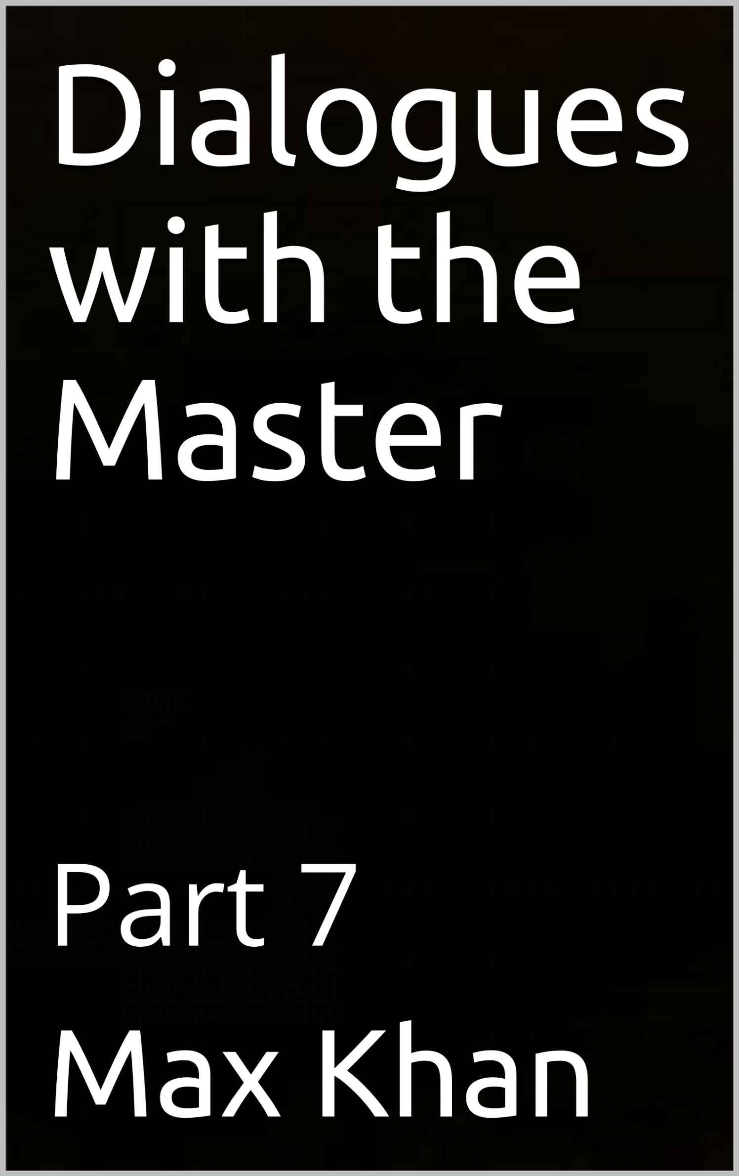

DIALOGUES WITH THE MASTER PART 7
MAX KHAN

MASTER: YOUR WRITING IS REALLY COMING ALONG, MY SON. IN THE LAST FEW WEEKS, YOU HAVE BEEN ASTONISHINGLY PRODUCTIVE. AND YOUR WRITING IS REALLY IMPROVING. YOU ARE WRITING WITH INCREASE EASE AND GRACE AND CLARITY.
STUDENT: THANK YOU, MASTER. BUT WHY AREN’T MY BOOKS SELLING? MASTER: BECAUSE YOUR WRITING HAS AN AGENDA. A BITTER AGENDA. STUDENT: BUT DOESN’T WRITING HAVE TO HAVE AN AGENDA TO BE GOOD?
MASTER: IT HAS TO HAVE AN OBJECTIVE. AN AGENDA ISN’T AN OBJECTIVE. IT IS A PSEUDO-OBJECTIVE.
STUDENT: SO BASICALLY, I SHOULDN’T VENT. I SHOULDN’T GRIPE. I SHOULD EXPRESS MYSELF.
MASTER: RIGHT. YOU SHOULD EXPRESS YOURSELF---BUT NOT EMOTE.
STUDENT: FOR EMOTING IS THE OPPOSITE OF EXPRESSING ONESELF. MASTER: EXACTLY. EMOTIONS ARE NOT ONESELF. THEY ARE THINGS THAT
HAPPEN TO ONESELF. AND FOR WRITING TO BE GOOD, IT MUST REFLECT WHAT ONE IS, NOT THE ACCIDENTS, BE THE INTERNAL OR EXTERNAL, THAT HAPPEN TO BEFALL ONE.
STUDENT: THIS IS DEEPLY GOOD ADVICE, MASTER. MAY I CHANGE THE SUBJECT?
MASTER: PLEASE.
STUDENT: IS PLEASURE WRONG? MASTER: NO. NOT AT ALL.
STUDENT: THEN WHY ARE SO MANY RELIGIONS OPPOSED TO IT.
MASTER: PLEASURE PER SE IS NOT WRONG. BUT PLEASURE PERSUED AT THE EXPENSE OF AGENCY---THE ABILITY TO DO AND THUS TO TRULY LIVE—IS WRONG.
STUDENT: AND THERE IS SOME TENDENCY FOR THE PURSUIT OF PLEASURE TO ENCROACH ON ONE’S AGENCY.
MASTER: THERE IS.
STUDENT: AND THEREIN LIES THE WRONGNESS OF PLEASURE.
MASTER: EXACTLY. BUT IT IS ONLY TO THAT EXTENT THAT PLEASURE IS WRONG. IN AND OF ITSELF, PLEASURE IS A GOOD THING.

STUDENT: MAY I CHANGE THE SUBJECT AGAIN, MASTER? MASTER: PLEASE.
STUDENT: AS YOU KNOW, MASTER, I AM FUNNY. MASTER: YES YOU ARE.
STUDENT: AND IF I WERE TO WRITE FUNNY MATERIAL, INSTEAD PHILOSOPHICAL OR OTHERWISE MOROSE MATERIAL, I MIGHT ACTUALLY MAKE MONEY FROM MY WRITING.
MASTER: YOU WOULD DEFINITELY MAKE MONEY FROM YOUR WRITING. STUDENT: BUT I FEEL THAT I WOULD BE SELLING OUT IF I DID SO. MASTER: THE OPPOSITE IS THE CASE.
STUDENT: HOW DO YOU MEAN?
MASTER: AS WE AGREED EARLIER, WRITING IS ABOUT EXPRESSING ONESELF. YOU ARE A HUMOROUS PERSON. NOT A GOOFY PERSON, BUT A WITTY PERSON WHO SEES MANY APSECTS OF LIFE AND WHOSE SENSE OF HUMOR IS A REFLECTION OF HIS ACUITY AND DEPTH OF PERCEPTION.
STUDENT: AND IN ORDER TO DO JUSTICE MYSELF AS A WRITER, I MUST EXPRESS THAT SIDE—THE HUMOROUS SIDE---OF MYSELF.
MASTER: EXACTLY.
STUDENT: AND THE REASON PEOPLE WOULD PAY ME TO DO IS THAT I WOULD BE RIGHT BE TO DO SO AND THEIR GIVING ME MONEY WOULD BE THEIR WAY OF SAYING AS MUCH.
MASTER: EXACTLY.
STUDENT: THEN THAT IS WHAT I SHALL DO, MASTER.

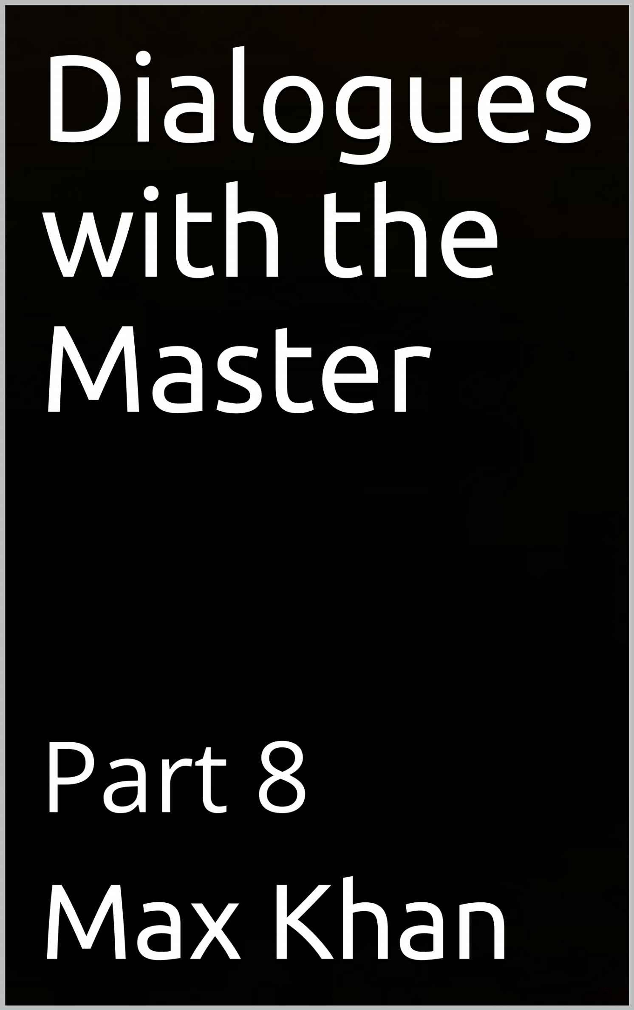

DIALOGUES WITH THE MASTER PART 8
MAX KHAN

STUDENT: MASTER, I HAVE HEARD THAT, AS CHILDREN, SERIAL KILLERS ARE CRUEL TO ANIMALS, WET THEIR BEDS, AND LIKE TO START FIRES.
MASTER: ALL TRUE.
STUDENT: WHAT ARE THESE BEHAVIORS ABOUT?
MASTER: THE BED WETTING IS ABOUT LACK OF CONSCIENCE. THE YOUNG SERIAL KILLER HAS SUCH DISREGARD FOR PROPRIETY AND DECENCY THAT HE THINKS NOTHING OF SULLYING HIS SHEETS AND THEN LEAVING TO OTHERS TO CLEAN UP THE MESS.
STUDENT: AND NOT ONLY DOES IT NOT BOTHER HIM TO DO IT. HE ACTIVELY LIKES IT. HE LIKES EXPRESSING HOSTILITY IN THAT WAY.
MASTER: EXACTLY.
STUDENT: AND CRUELTY TO ANIMALS? WHAT IS THAT ABOUT?
MASTER: YOU NOTICE THAT MANY A PERSON WHO IS OTHERWISE GROUCHY OR ANTI-SOCIAL IS VERY TENDER TOWARDS HIS PETS. IN GENERAL, PEOPLE’S FEELINGS TOWARDS ANIMALS REPRESENT THEIR HIDDEN FEELINGS TOWARDS OTHERS.
STUDENT: I THINK I UNDERSTAND. SO A GIVEN PERSON MIGHT SEEM GROUCHY AND DIFFICULT ON THE OUTSIDE, EVEN THOUGH, DEEP DOWN, HE IS GOOD. AND HIS GOODNESS COMES OUT IN HIS KINDNESS TO PUPPIES AND KITTENS, AND SO FORTH.
MASTER: CORRECT.
STUDENT: CONTRARIWISE, WICKEDNESS TOWARDS THESE HARMLESS LOVABLE LITTLE CREATURES BESPEAKS A TRULY BLACK HEART.
MASTER: PRECISELY.
STUDENT: AND THAT IS WHY THE SERIAL KILLER IS CRUEL TO ANIMALS. MASTER: YES.
STUDENT: AND WHAT ABOUT THE PYROMANIA? WHY ARE SERIAL KILLERS, AS CHILDREN, PYROMANIACS?
MASTER: BURNING THINGS IS THE MOST EXTREME, THE MOST ENCOMPASSING AND TOTAL, WAY OF DESTROYING THEM. LIGHTNING A FIRE IS LIKE SETTING OFF A MINIATURE NUCLEAR BOMB.
STUDENT: I SEE. THE SERIAL KILLER WANTS TO RAZE THE EARTH TO THE GROUND. SO HE SETS FIRES.

MASTER: THAT’S RIGHT.
STUDENT: ARE ALL PEOPLE WHO WET THEIR BEDS AS CHILDREN PSYCHOPATHS? MASTER: BY NO MEANS. SOMETIMES THEY ARE VERY GOOD PEOPLE.
STUDENT: WHEN DO GOOD PEOPLE WET THEIR BED AS CHILDREN? MASTER: WHEN THEY ARE DEEPLY ANGRY.
STUDENT: THERE IS AN ESSAY BY GEORGE ORWELL CALLED ‘SUCH, SUCH WERE THE JOYS.’ IT IS ABOUT HIS GRIM EXPERIENCE AT BOARDING SCHOOL.
MASTER: YES, IT’S A WONDERFUL ESSAY.
STUDENT: AT THE BEGINNING, ORWELL TALKS ABOUT HOW, WHEN HE FIRST GOT TO BOARDING TO SCHOOL, HE COULDN’T STOP WETTING HIS BED.
MASTER: EXACTLY. HE WAS DEEPLY ANGRY ABOUT BEING THERE. STUDENT: THAT MAKES SENSE.
MASTER: INDEED.
STUDENT: THANK YOU MASTER.

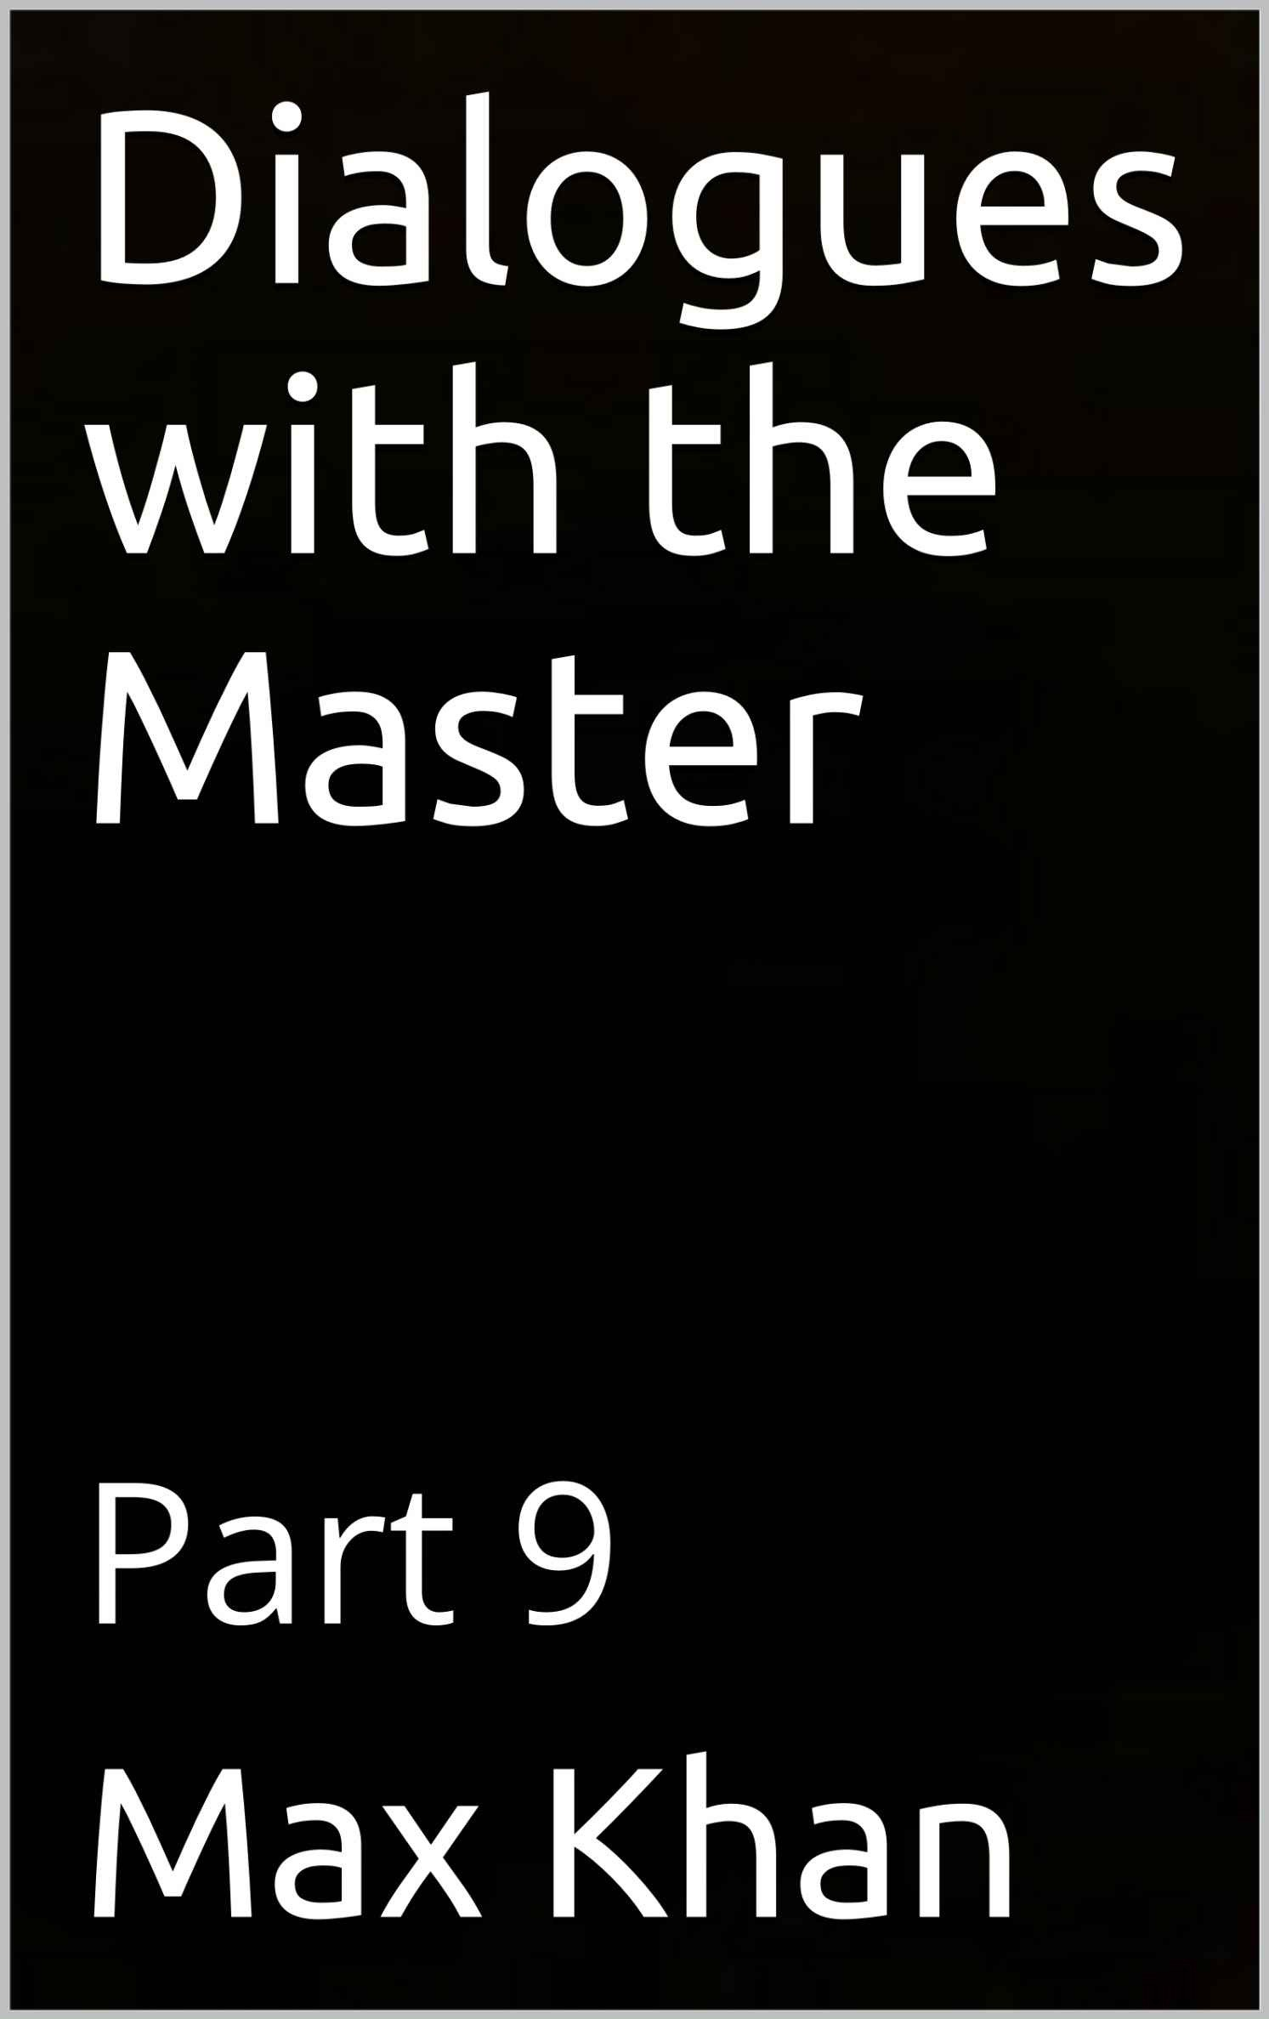

DIALOGUES WITH THE MASTER PART 9
MAX KHAN

STUDENT: MASTER, I WORK SO HARD, AND I DO SUCH GOOD WORK. AND YET I MAKE SO LITTLE MONEY.
MASTER: YES, YOU DO A LOT OF WORK, AND YOU WORK IS GOOD. AND YES, YOU MAKE VERY LITTLE MONEY.
STUDENT: SO WHAT’S THE EXPLANATION, MASTER?
MASTER: MAKING MONEY IS ABOUT GIVING PEOPLE WHAT THEY WANT, NOT WHAT YOU WANT. WHEN YOU SAY THAT YOU DO ‘GOOD’ WORK, WHAT YOU MEAN IS THAT YOU DO WORK THAT SATISFIES THE STANDARDS THAT ARE IMPORTANT TO YOU.
STUDENT: THAT’S RIGHT.
MASTER: AND WHEN YOU SAY THAT YOU A LOT OF WORK, WHAT YOU ARE SAYING IS THAT YOU DO LARGE QUANTITIES OF WORK THAT SATISFIES YOUR PARTICULAR STRICTURES.
STUDENT: YES, BUT THOSE STRICTURES ARE LEGITIMATE ONES.
MASTER: I HAVE NO DOUBT ABOUT THAT, MY SON. I HAVE NO DOUBT THAT, FROM SOME PLATONIC VIEWPOINT, THEY ARE INDEED THE RIGHT STANDARDS. BUT SOMEONE PURCHASES A PRODUCT, THEIR INTENTION IS TO SATISFY THEIR NEEDS, AND THEIR NEEDS ARE NOT ALWAYS GOING IN PERFECT ALLIGNMENT WITH THE STRICTURES OF A CRAFTSMAN WHOSE PRIMARY CONCERN IS BEING ON THE RIGHT SIDE OF PLATONIC ARCHETYPE.
STUDENT: I THINK I AM BEGINNING TO UNDERSTAND. THE PERSON WHO WRITES THE BOOK MAY DO SO WITH THE INTENTION OF PRODUCING PERFECT PROOFS, BUT THE PERSON WHO BUYS THE BOOK DOES SO WITH THE INTENTION OF FILLING CERTAIN GAPS IN HIS UNDERSTANDING, WHICH ARE NOT LIKELY TO COINCIDE WITH ALL OF THE LITTLE NUANCES TO WHICH THE AUTHOR WAS SO PUNCTILLIOUS IN ATTENDING.
MASTER: EXACTLY. BUT THERE IS ANOTHER DIMENSION TO THIS. STUDENT: EXPLAIN, MASTER.
MASTER: YOUR ARE AN AUTHOR. BOOKS ARE YOUR PRODUCT. IDEAS ARE YOUR PRODUCT. A BOOK IS MEANT TO SERVE A NUMBER OF FUNCTIONS: SOME OF THEM PURELY LOGICAL, SOME OF THEM INFORMATION-TRANSMISSIVE, SOME OF THEM SOCIAL, SOME OF THEM EMOTIONAL.
STUDENT: I FOLLOW
MASTER: AND YOUR BOOKS DEFINITELY HAVE THE LOGIC PARAMETER DOWN.

AND TO A LESSER EXTENT THEY HAVE THE INFORMATION-TRANSMISSION PARAMETER DOWN.
STUDENT: I THINK I SEE WHERE YOU ARE GOING. BUT THERE ARE OTHER PARAMETERS RELATIVE TO WHICH MY BOOKS FALL SHORT, AND UNLESS THOSE PARAMETER ARE ADDRESSED, TRYING TO GET PEOPLE TO INTERNALIZE THEIR CONTENTS IS LIKE TO TRYING TO RUN A PROGRAM ON A COMPUTER SYSTEM WITH WHICH THAT PROGRAM IS NOT COMPATIBLE.
MASTER: EXACTLY. AND YOU SAY THAT YOUR WORK IS GOOD, WHICH IT IS, YOU ARE SAYING THAT, RELATIVE TO CERTAIN PARAMETERS, IT IS GOOD.
STUDENT: BUT THOSE PARAMETERS ARE NOT THE ONLY ONES.
MASTER: NO THEY ARE NOT. BUT—AND THIS IS THE POINT THAT I WAS ABOUT TO MAKE A MOMENT AGO---OFTENTIMES OVER-FOCUSING ON ASPECT OF A BOOK IS ABOUT AVOIDANCE.
STUDENT: AVOIDANCE?
MASTER: YES, BY OVERFOCUSING ON LOGICAL MINUTIAE AND DISMISSIVELY DISREGARDING THE EMOITONAL AND SOCIAL FUNCTIONS OF BOOKS, ONE IS PRODUCING MATERIAL THAT IS, IN SOME OJBETIVE SENSE, STERILE AND LACKING IN DEPTH.
STUDENT: I SEE. THE EMOTIONAL AND SOCIAL FUNCTIONS OF A BOOK ARE ACTUALLY DIFFERENT MANIFESTATIONS OF ITS LOGICAL AND INFORMAITON- TRANSMISSIVE FUNCTIONS.
MASTER: RIGHT, AND BY DISREGARDING THE FORMER ASPECTS OF A BOOK, ONE IS ALSO, ULTIMATLEY, DISREGARDING THE LATTER.
STUDENT: THANK YOU MASTER, THIS HAS BEEN ILLUMINATING. ILLUMINATING AND HUMANIZING AND CENTERING.
MASTER: YOU ARE WELCOME, MY SON.

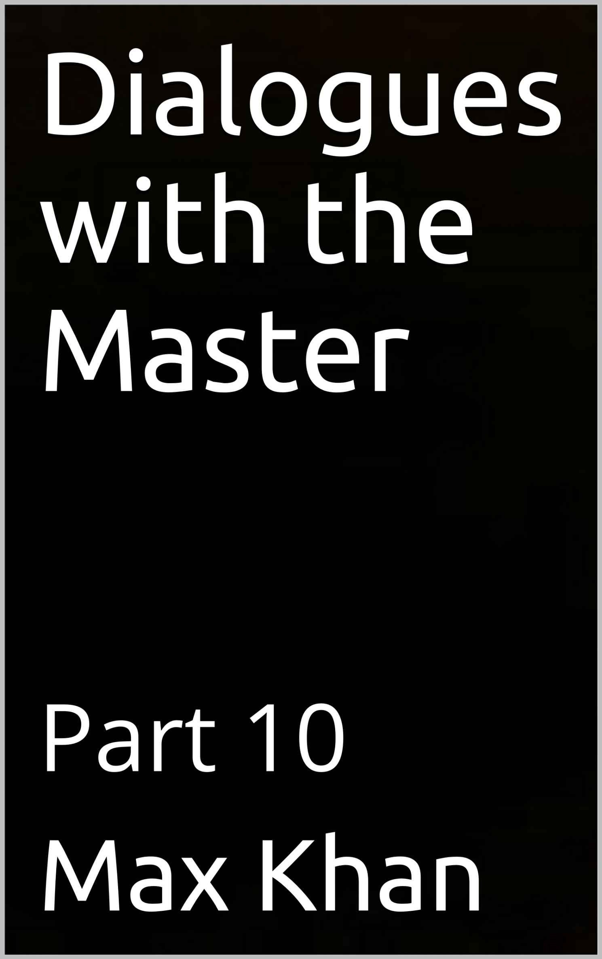

DIALOGUES WITH THE MASTER PART 10
MAX KHAN

STUDENT: MASTER, THE LAST TIME WE SPOKE, WE DISCUSSED THE FACT THAT MY WRITING IS NOT MAKING ANY MONEY.
MASTER: YES THAT’S RIGHT. YOUR WRITING IS EXCELLENT. AND THERE IS LOTS OF IT. BUT IT ISN’T MAKING ANY MONEY. AND THAT IS INDEED WHAT WE DISCUSSED.
STUDENT: AND YOU IDENTIFIED ONE REASON WHY IT ISN’T MAKING MONEY. MASTER: BUT…?
STUDENT: BUT I FEEL THAT SOMETHING IMPORTANT WAS LEFT UNSAID. MASTER: YOU ARE RIGHT. THE MOST IMPORTANT THING WAS LEFT UNSAID. STUDENT: AND WHAT WAS THAT?
MASTER: YOU WORK VERY HARD, AND YOUR WORK IS VERY GOOD. VERY PURE. BUT THAT’S THE PROBLEM. IT’S TOO PURE. AND YOU WORK TOO HARD.
STUDENT: PLEASE EXPLAIN, MASTER.
MASTER: MAKING MONEY IS ULTIMATLEY ABOUT BEING EMOTIONALLY CONNECTED TO OTHER PEOPLE. IT ISN’T SIMPLY ABOUT PRODUCING A PRODUCT THAT IS GOOD IN SOME DERACINATED PURELY PLATONIC SENSE. IT IS ABOUT PRODUCING SOMETHING THAT IS GOOD IN MANY SENSES, LOGICAL, SOCIAL, AND EMOTIONAL.
STUDENT: YES, WE DISCUSSED THIS.
MASTER: RIGHT. BUT HERE’S WHAT WE DIDN’T DISCUSS. IF YOU WORK TOO HARD—IF YOU WORK LIKE A MANIAC—YOU ARE, FOR THAT VERY REASON, FOCUSED ON PRETTY MUCH EVERYTHING EXCEPT OTHER PEOPLE.
STUDENT: I THINK I AM BEGINNING TO UNDERSTAND.
MASTER: WORKING COMPULSIVELY---WORKING WITH MANIACAL FERVOR---IS ABOUT ESCAPISM. ONE IS RUNNING FROM ONESELF.
STUDENT: AND ONE IS THEREFORE RUNNING FROM ONE’S OWN EMOTIONS.
MASTER: EXACTLY. AND ONE MUST BE IN TOUCH WITH ONE’S OWN EMOTIONS IF ONE IS TO BE IN TOUCH WITH OTHER PEOPLE’S EMOTIONS.
STUDENT: AND ONE MUST BE IN TOUCH WITH OTHER PEOPLE’S EMOTIONS IF ONE IS PRODUCE WORK THAT IS IN ALLIGNMENT WITH THOSE EMOTIONS.
MASTER: EXACTLY.
STUDENT: AND BY VIRTUE OF BEING IN ALLIGNMENT WITH THEM, THAT

PRODUCT WILL, IN SOME OBJECTIVE SENSE, BE MORE INFORMATIVE, AND RICHER IN INFORMAITON—AND IN THE ABILITY TO CONVEY—THAN IT WOULD OTHERWISE BE.
MASTER: EXACTLY. SO YOU WOULD MAKE MORE MONEY, AND DO BETTER WORK, IF YOU WORKED LESS STRENUOUSLY.
STUDENT: BECAUSE EXCESSIVELY STRENUOUS WORK IS ABOUT NEUROTIC ESCAPISM.
MASTER: RIGHT. AND NOBODY PAYS FOR NEUROSIS.
STUDENT: THEY PAY FOR THE OPPOSITE OF NEUROSIS, WHATEVER THAT IS.
MASTER: EXACTLY. SO BE EASIER ON YOURSELF. DON’T BE SELF-INDULGENT, BUT BE BALANCED AND SANE. AND ENJOY LIFE, AND BE MINDFUL OF YOUR OWN FEELINGS.
STUDENT: AND THAT WILL MAKE MINDFUL OF OTHER PEOPLE’S FEELINGS, AND I WILL PRODUCE A MORE MARKETABLE PRODUCT.
MASTER: EXACTLY.
STUDENT: THANK YOU, MASTER.

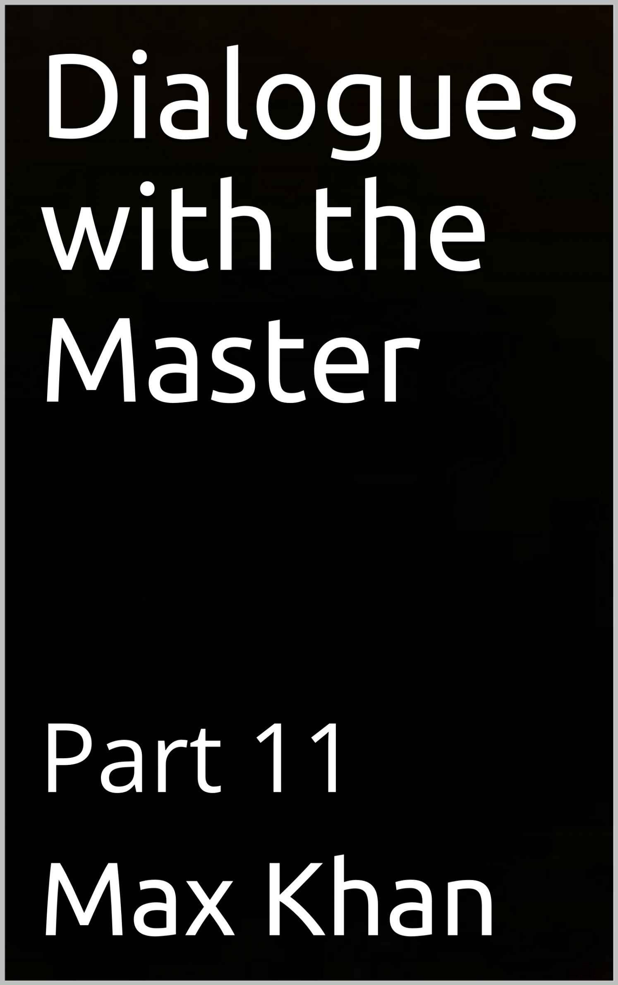

DIALOGUES WITH THE MASTER PART 11
MAX KHAN

STUDENT: MASTER, OTHER PEOPLE CAN BE SO HORRIBLE. SOMETIMES I JUST WANT TO LIVE IN SOLITUDE, AWAY FROM ALL OTHERS.
MASTER: A LIFE OF SOLITUDE WOULD HAVE NO MEANING. STUDENT: I DO NOT UNDERSTAND, MASTER.
MASTER: YOU THINK YOU WANT SOLITUDE, MY SON. BUT WHAT YOU REALLY WANT IS GOOD COMPANY.
STUDENT: I THINK I UNDERSTAND, MASTER.
MASTER: AND WHAT YOU CALL SOLITUDE IS NOT REALLY SOLITUDE. IT IS TIME SPENT AWAY FROM BAD PEOPLE, SO THAT YOU CAN ENJOY THE MEMORIES YOU HAVE OF THE GOOD PEOPLE YOU HAVE BEEN WITH.
STUDENT: THAT MAKES SENSE, MASTER.
MASTER: AND ALTHOUGH THERE ARE ACTIVITIES THAT MUST BE PURSUED IN SOLITUDE, THEIR MEANING LIES ULTIMATELY THE UNIONS WITH OTHER PEOPLE THAT THOSE ACTIVITIES HELP EFFECTUATE.
STUDENT: I THINK I UNDERSTAND. SO WRITING A BOOK OR COMPOSING A SYMPHONY OR DISCOVERING A CURE---THESE ARE ACTIVITIES THAT MUST BE DONE IN SOLITUDE. BUT UNLESS SOMEONE ELSE READ THE BOOK, OR LISTENED TO THE SYMPHONY, OR BENEFITED FROM THE CURE, THOSE ACTIVITIES WOULD BE DRAINED OF MEANING.
MASTER: EXACTLY.
STUDENT: AND IT IS NOT BECAUSE OF ANY DEFICIENCY ON THE PART OF HUMAN BEINGS THAT THEY NEED EACH OTHER. IT IS INHERENT IN WHAT IT IS TO BE HUMAN THAT PEOPLE NEED PEOPLE.
MASTER: THAT BEING WHY ARISTOTLE SAID THAT ONLY A BEAST AND A GOD CAN EXIST IN SOLITUDE.
STUDENT: AND HOW DOES ROMANTIC LOVE FIT INTO ALL THIS, MASTER?
MASTER: LOVE BETWEEN A MAN AND A WOMAN IS A PARTICULARLY PURE AND DEEP MANIFESTATION OF THE INTERCONNECTEDNESS BETWEEN HUMAN BEINGS THAT GIVES LIFE MEANING.
STUDENT: BUT THEN WHY DOES SUCH LOVE SO OFTEN ASSUME SUCH VULGAR AND PRURIENT FORMS?
MASTER: THE FACT THAT IT CAN ASSUME SUCH DEBASED FORMS IS A CONSEQUENCE OF THE FACT THAT, WHEN IT IS NOT DEBASED, IT IS SO

MEANINGFUL.
STUDENT: I SEE. THE POTENCY INHERENT IN SUCH RELATIONSHIPS CAN BE EXPRESSED IN MANY DIFFERENT WAYS, SOME OF THEM EMOTIONALLY GOOD, SOME OF THEM EMOTIONALLY BAD, SOME OF THEM PURELY CARNAL.
MASTER: EXACTLY. AND THAT POTENCY CAN MAKE SUCH RELATIONSHIPS AS CRUDE AND CARNAL AS IT CAN ALSO MAKE THEM SUBLIME.
STUDENT: DOES THAT MEAN THAT CARNALITY IS BAD OR DOES IT MEAN THAT IT IS SUBIMITY IN DISGUISE?
MASTER: THE LATTER, MY SON. WITHOUT CARNALITY, LIFE WOULD BE DRAINED OF MEANING.
STUDENT: JUST AS WITHOUT OTHER PEOPLE, SOLITUDE WOULD BE DRAINED OF ITS MEANING, ITS MEANING BEING THAT IT GIVES SIGNIFICANCE TO HUMAN RELATIONSHIPS.
MASTER: AND THE MEANING OF CARNALITY BEING THAT IT GIVES SIGNIFICANCE TO ROMANTIC LOVE.
STUDENT: THANK YOU, MASTER. THIS HAS BEEN INFORMATIVE.

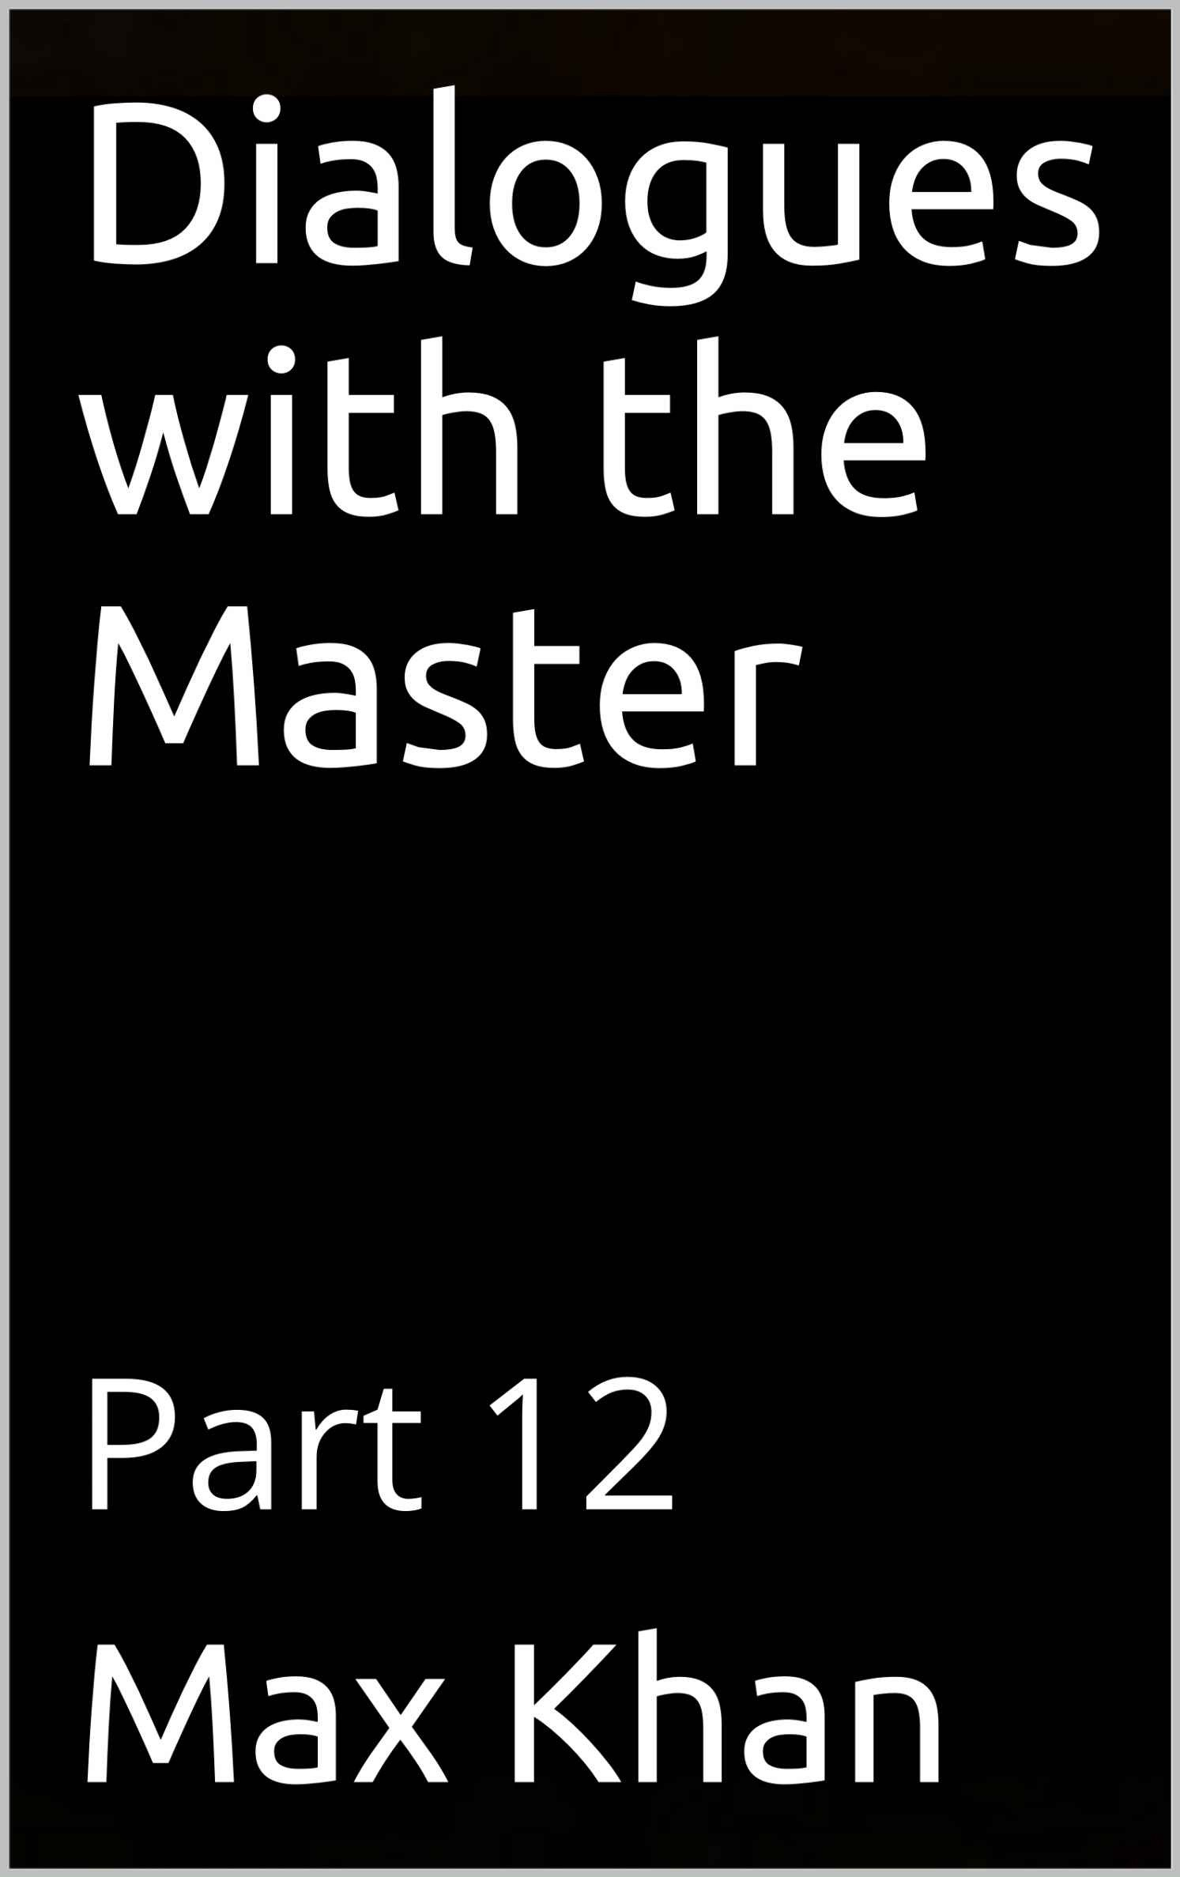

DIALOGUES WITH THE MASTER PART 12
MAX KHAN

STUDENT: MASTER, AS YOU KNOW, I SUFFER FROM TERRIBLE OCD. MASTER: I KNOW, MY SON.
STUDENT: I HAVE BEEN LOOKING ONLINE FOR WAYS TO RID MYSELF OF IT. THERE ARE MANY EXPERTS OUT THERE. I MEAN, THERE ARE MANY LEGITIMATE EXPERTS. MANY PEOPLE WHO VERY CLEARLY HAVE A DEEP UNDERSTANDING OF THE ILLNESS AND HAVE VERY DEFINITE VIEWS AS TO HOW ONE IS TO RID ONESELF OF IT.
MASTER: THAT SHOULD BE GOOD NEWS FOR YOU. STUDENT: IT ISN’T.
MASTER: WHY NOT?
STUDENT: BECAUSE EVEN THOUGH EACH OF THESE EXPERTS UNDERSTANDS THE INTRICACIES OF THIS CONDITION, NONE OF THEM HAS A SIMPLE, WELL- DEFINED PROPOSAL AS TO HOW TO GET RID OF IT. EACH HAS PROPOSED A VERY COMPLEX AND DRAWN OUT REGIMEN OF BEHAVIORAL CONDITIONING.
MASTER: I THINK I FOLLOW YOU MY SON. EACH OF THESE COURSES OF THERAPY, PRECISELY BECAUSE IT IS SO COMPLEX AND DRAWN OUT, IS UNLIKELY TO EFFECTUATE ANY REAL CHANGE.
STUDENT: EXACTLY.
MASTER: THE VERY FACT THAT EACH SUCH PROGRAM IS SO INTRICATE AND PROLONGED SUGGESTS THAT THE PERSON WHO DESIGNED HAS NOT QUITE CRACKED THE CODE.
STUDENT: EXACTLY. EACH OF THESE THERAPISTS IS LIKE A TALENTED NOVELIST WHO CAN’T QUITE FIGURE OUT THE PLOT FOR HIS NOVEL. SO HE JUST WRITES AND WRITE AND WRITES, AND GENERATES 900 PAGES OF MATERIAL THAT IS GOOD IN ITS WAY BUT THAT LACKS FOCUS AND IS THEREFORE ULTIMATELY NOT GOOD.
MASTER: NO WORRIES. I WILL NOW TELL YOU WHAT OCD IS ABOUT, AND I WILL THEN TELL YOU HOW TO GET RID OF IT.
STUDENT: SPEAK, MASTER. ENLIGHTEN.
MASTER: OCD IS ABOUT IMPOTENCE. IT IS ABOUT IMPOTENT RAGE. AND THE VARIOUS SYMPTOMS---THE VARIOUS OBSESSIONS AND COMPULSIONS---ARE SO MANY DIFFERENT WAYS EXPRESSIONS OF ONE’S IMPOTENCE-BORN FEELIGNS

OF VULNERABILITY AND ANGER. STUDENT: THAT RINGS TRUE, MASTER.
MASTER: AND THE WAY TO GET OVER OCD IS TO ACQUIRE POWER. STUDENT: EXPLAIN, MASTER.
MASTER: POWER IS ABILITY COMBINED WITH RESOURCES.
STUDENT: SO IF I DEVELOP MY TALENTS, AND I THEN PROCEED TO MONETIZE THEM, THEN I WILL HAVE POWER. AND THEN I WILL NO FEEL IMPOTENT.
MASTER: RIGHT. YOU WILL NO LONGER FEEL IMPOTENT, BECAUSE YOU WILL NO LONGER BE IMPOTENT.
STUDENT: AND THEN I WILL NO LONGER HAVE OCD. MASTER: THAT IS CORRECT.
STUDENT: AND HOW DO PROCEED TO ACQUIRE THIS POWER?
MASTER: YOU ACQUIRE IT BY ADDING TO THE POWER THAT YOU ALREADY HAVE.
STUDENT: EXPLAIN.
MASTER: YOU ARE NOT COMPLETELY WITHOUT POWER. YOU ARE INTELLIGENT. AND YOU HAVE THE ABILITY TO EXERCISE JUDGMENT. AND WITHIN THE LIMITS SET BY YOUR OCD, YOU ARE SANE. AND THAT RIGHT THERE---THAT CONFLUENCE OF FACTORS—IS POWER. REAL POWER.
STUDENT: AND BY EXERCIZING MY JUDGMENT, I WILL STRENGTHEN MY AGENCY. AND ON THE BASIS OF MY NEWLY STRENGTHENED AGENCY, I CAN CULTIVATE MY ABILITIES.
MASTER: AND ON THAT BASIS, YOU CAN FURTHER CONSOLIDATE YOUR AGENCY AND HONE YOUR POWERS OF JUDGMENT.
STUDENT: LIKE AN ENTREPRENEUR WHO MAKES A SMALL PROFIT, WHICH INVESTS BACK INTO HIS BUSINESS, FURTHER ADDING TO HIS PROFITS.
MASTER: EXACTLY, AND THROUGH REPEATED ITERATIONS OF THIS BOOTSTRAPPING PROCESS, YOU WILL EVENTUALLY ACQUIRE GREAT POWER.
STUDENT: AT WHICH POINT I WILL LONGER BE VULNERABLE AND WILL THEREFORE NO LONGER FEEL THE NEED TO TAKE REFUGE IN THE SAFETY—OR PSEUDO-SAFETY, RATHER---OF THE MADNESS THAT IS OCD.
MASTER: PRECISELY.
STUDENT: THANK YOU, MASTER. THIS HAS BEEN ENLIGHTENING. MASTER: JUST REMEMBER, MY SON. DON’T PANIC. ALWAYS USE YOUR
JUDGMENT. THIS WILL MAKE YOU STRONGER, AND IN DUE COURSE, YOU WILL
ONCE AGAIN BE WHOLE.

STUDENT: AGREED, MASTER.

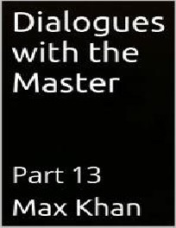

DIALOGUES WITH THE MASTER PART 13
MAX KHAN

STUDENT: MASTER, I AM SO POOR. I HAVE NOTHING. I AM SO AFRAID. I AM SO ASHAMED.
MASTER: AND IF YOU HAD MONEY, YOU WOULD NOT BE ASHAMED? STUDENT: THAT’S RIGHT, MASTER.
MASTER: YOU’RE THINKING IS MISCONCEIVED, MY SON. MISCONCEIVED AND SELF-DEFEATING. NEEDLESSLY SELF-DEFEATING.
STUDENT: PLEASE EXPLAIN, MASTER.
MASTER: HAPPINESS DOES NOT DEPEND ON WHAT YOU ARE. IT DEPENDS ENTIRELY ON WHAT YOU THINK.
STUDENT: SO WHAT I AM IS NOT WHAT I HAVE. IT IS WHAT I THINK.
MASTER: YES. YOUR POSSESSIONS ARE EXTERNAL TO YOU. YOUR THOUGHTS ARE INTERNAL TO YOU. THEY ARE YOU.
STUDENT: SO MY POSSESSIONS DEFINE MY CIRCUMSTANCES, BUT MY THOUGHTS DEFINE MY IDENTITY.
MASTER: YES.
STUDENT: BUT I NOT ONLY HAVE NO MONEY, MASTER. I ALSO HAVE NO STATUS. I HAVE NO TITLE, NO POSSESSION, NO EMINENCES OF ANY KIND.
MASTER: ASKED AND ANSWERED, MY SON. STUDENT: HOW DO YOU MEAN, MASTER?
MASTER: YOU ARE NOT YOUR POSSESSIONS. NOR ARE YOU YOUR STATUS OR RANK. YOUR IDENTITY LIES IN YOUR THOUGHTS, NOT IN EXTERNALITIES. NOT IN POSSESSIONS OR RANK OR STATUS.
STUDENT: I SEE. SO MUST I SPURN WEALTH AND STATUS.
MASTER: NO. SPURNING WEALTH AND RICHES IS A WAY OF CONTINUING TO COVET THEM.
STUDENT: I DO NOT UNDERSTAND, MASTER.
MASTER: IN SPURNING MONEY AND STATUS, YOU ARE LIKE A GIRL WHO TELLS HERSELF THAT SHE HATES SOME BOY WHO IS REJECTING HER ADVANCES. SPURNING REALITY IS A WAY OF CLINGING TO IT.
STUDENT: YOU MEAN, IT IS A WAY OF CLINGING TO ITS UNDERBELLY. MASTER: EXACTLY.
STUDENT: AND THE RIGHT APPROACH, THE SANE APPROACH, IS THE NON- REACTIVE APPROACH.
MASTER: EXACTLY. WEALTH AND STATUS ARE THINGS THAT YOU HAVE. THEY ARE NOT WHAT YOU ARE. THEREFORE, YOU SHOULD NOT TREAT THEM AS

THOUGH YOUR IDENTITY DEPENDEND ON THEM. FOR IT DOESN’T. AT THE SAME TIME, YOU SHOULD NOT REJECT THEM OUT OF HAND. FOR THAT TOO IS A WAY OF OVERVALUING THEM.
STUDENT: I SHOULD SEE THEM FOR WHAT THEY ARE, MEANS TO AN END. THE END BEING CIRCUMSTANCES THAT GIVE THE TIME AND FREEDOM AND WHEREWITHAL TO LIVE AUTHENTICALLY.
MASTER: EXACTLY. OVER-VALUING POSSESSIONS IS A WAY OF POSSESSED BY ONE’S POSSESSIONS.
STUDENT: AND SPURNING ALL POSSESSIONS IS ITSELF A WAY, A CIRCUITOUS WAY, OF OVER-VALUING POSSESSIONS.
MASTER: AND THEREFORE OF BEING POSSESSED BY THEM.
STUDENT: AND THE RIGHT APPROACH IS TO POSSESS ONE’S POSSESIONS, NOT BE POSSESSED BY THEM.
MASTER: EXACTLY.
STUDENT: WHICH ONE DOES BY HAVING A SANE AND MODERATE ATTITUDE TOWARDS MONEY AND STATUS AND OTHER SUCH EARTHLY GOODS.
MASTER: YOU LEARN QUICKLY, MY SON.

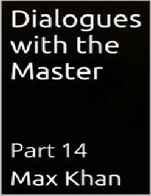

DIALOGUES WITH THE MASTER PART 14
MAX KHAN

STUDENT: MASTER, I HAVE BEEN WRONGED SO OFTEN. I CANNOT STOP THINKING ABOUT THE INJUSTICES THAT I HAVE SUFFERED.
MASTER: AND WHAT DO YOUR RUMINATIONS AVAIL YOU? STUDENT: WELL, NOTHING, I SUPPOSE.
MASTER: IF THEY LED TO ACTION, THAT WOULD BE ONE THING. BUT THEY DON’T.
STUDENT: NO, THEY DON’T.
MASTER: SO WHAT DO AVAIL YOU OF? STUDENT: NOTHING, I SUPPOSE.
MASTER: NOTHING EXCEPT FOR THE NEGATIVITY WITH WHICH THEY FILL YOUR MIND.
STUDENT: YES, THAT’S RIGHT. MASTER: AND THE WASTED TIME. STUDENT: EXPLAIN, MASTER.
MASTER: WHEN YOU ARE DWELLING ON THE WRONGS YOU HAVE EXPERIENCED, YOU ARE NOT ACTING. YOU ARE NOT IMPROVING YOUR LOT.
STUDENT: THAT IS TRUE.
MASTER: WHICH MEANS THAT YOU ARE GIVING LONGEVITY TO THE VARIOUS SLIGHTS THAT YOU HAVE EXPERIENCED IN THE PAST. IF YOU MOVED ON, THEY WOULD DRIFT AWAY, INTO THE OBLIVION OF THE PAST. BUT BY DWELLING ON THEM, YOU MAKE THEM PRESENT.
STUDENT: I KEEP THEM ALIVE, IN OTHER WORDS.
MASTER: EXACTLY. ALIVE AND KICKING. SO THAT THEY CAN STILL HURT YOU. STUDENT: BUT IF I MOVED ON, THEY COULDN’T HURT ME.
MASTER: AND BY MOVING ON, YOU WOULD BE ACTING, AND THEREFORE IMPROVING YOUR LOT, AND THEREFORE STRENGTHENING YOURSELF.
STUDENT: AND THEREFORE MAKING MYSELF INVULNERABLE TO FUTURE SLIGHTS AND INJURIES.
MASTER: AND ALSO DIMINISHING THE DAMAGING EFFECTS THAT PAST SLIGHTS AND INJURIES CAN HAVE YOU.
STUDENT: DOES THAT MEAN THAT I SHOULD FORCE MYSELF TO FORGET ALL OF THE INJURIES THAT I HAVE EXPERIENCED.
MASTER: NO. FOR THEN YOU WOULD BE DOOMED TO RE-EXPERIENCE THEM. STUDENT: I SEE.

MASTER: MORE IMPORTANTLY, WILLFULLY FORGETTING THE PAST IS A WAY OF CLINGING TO IT.
STUDENT: PLEASE EXPLAIN MASTER.
MASTER: BY REFUSING TO COP TO AN UGLY REALITY, ONE GIVES IT THE POWER TO ENGULF ALL OF REALITY. BUT BY ACKNOWLEDGING AN UGLY REALITY, AND REACTING IN A SANE AND JUDICIOUS MANNER TO IT, IT BECOMES DULY FINITE AND MANAGEABLE.
STUDENT: SO FORGETFULNESS IS ESCAPISM. AND ESCAPISM IS REALLY ABOUT CLINGING.
MASTER: RIGHT. RUNNING FROM THE PAST IS A WAY OF CLINGING TO IT. STUDENT: IT IS A WAY OF UNCONSCIOUSLY CLINGING TO IT.
MASTER: AND RUMINATING ABOUT IT IS A WAY OF CONSCIOUSLY CLINGING TO IT.
STUDENT: AND THE RIGHT APPROACH IS NOT TO CLING IT.
MASTER: THAT’S RIGHT. ONE SHOULD ACKNOWLEDGE IT, AS ONE SHOULD ALL REALITIES. AND ONE SHOULD USE ONE’S ACKNOWLEDGEMENT OF IT---ONE’S CONSCIOUSNESS OF IT---AS A WAY OF MASTERING IT.
STUDENT: WHEREAS WHEN ONE RUMINATES ABOUT IT, OR TRIES TO FLEE FROM IT, ONE IS NOT MASTERING IT; ONE IS BEING MASTERED BY IT.
MASTER: THAT’S RIGHT.
STUDENT: WE ACHIEVE FREEDOM NOT THROUGH FLIGHT. NOR YET BY SEETHING AND STEWING, BUT BY USING OUR JUDGMENT AND MAKING THE PIECEMEAL IMPROVEMENTS TO OUR SITUATION DEMANDED THEREBY.
MASTER: YOU LEARN QUICKLY, MY SON.

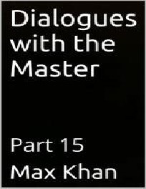

DIALOGUES WITH THE MASTER PART 15
MAX KHAN

STUDENT: MASTER, WHEN WE LAST SPOKE, WE DISCUSSED WHY IT IS IMPORTANT NOT RUMINATE.
MASTER: YES. BY RUMINATING, YOU ACCOMPLISH NOTHING AND YOU MERELY FILL YOUR MIND UP WITH NEGATIVITY.
STUDENT: YES. ACTION-CRIPPLING NEGATIVITY. MASTER: THAT IS RIGHT, MY SON.
STUDENT: AND BY PREVENTING ACTION, RUMINATION MAKES ONE MORE VULNERABLE TO THE VERY INJURIES AND PAST INJUSTICES THAT ONE IS RUMINATING ABOUT.
MASTER: CORRECT.
STUDENT: YOU ALSO MADE ANOTHER POINT. MASTER: AND WHAT WAS THAT, MY SON?
STUDENT: ACTUALLY, IT ISN’T SO MUCH A POINT THAT YOU EXPLICITLY, AS IT IS ONE THAT WAS IMPLICIT IN WHAT YOU SAID.
MASTER: AND WHAT WAS THAT POINT, MY YOUNG FRIEND?
STUDENT: THAT THE MIND IS EVERYTHING. THAT ONE’S REALITY IS INDISTINGUISHABLE FROM ONE’S MIND.
MASTER: WELL STATED.
STUDENT: A COROLLARY BEING THAT, IF ONE FILLS ONE’S MIND WITH NEGATIVITY, ONE IS THEREBY FILLING ONE’S REALITY WITH NEGATIVITY.
MASTER: CORRECT. THERE IS ANOTHER POINT, NOT EXACTY A COROLLARY OF THE POINT YOU JUST MADE, BUT RELATED TO IT.
STUDENT: AND WHAT IS THAT POINT, MASTER?
MASTER: THAT MOST PROBLEMS, IF GIVEN ENOUGH TIME, WEAR THEMSELVES OUT?
STUDENT: THAT IS QUITE STRIKING, MASTER? MASTER: HOW DO YOU MEAN, MY YOUNG FRIEND?
STUDENT: AFTER YOU TOLD ME NOT TO RUMINATE, I STOPPED DOING SO. AND I ADOPTED A MORE ACTION-ORIENTED, AS OPPOSED TO RUMINATION-ORIENTED, APPROACH TO REALITY.
MASTER: THAT’S GOOD.
STUDENT: AND WHAT I FOUND IS THAT MY PROBLEMS---THE ONES THAT I HAD PREVIOUSLY BEEN IN THE HABIT OF STEWING OVER---WOULD SIMPLY ERODE. NOT IMMEDIATELY. NOT QUICKLY. BUT STEADILY.
MASTER: ‘ERODE’ IS THE RIGHT WORD. PROGRESS IS USUALLY INCREMENTAL.

AN EMPTY JUG IS FILLED DROP BY DROP.
STUDENT: THAT IS A THEME THAT CONTINUES TO COME UP IN OUR EXCHANGES, AND I FIND IT TO BE A HELPFUL AND CENTERING ONE.
MASTER: WHAT IS THAT, MY SON?
STUDENT: THAT PROGRESS IS STEADY. THAT, AS AESOP SAID, SLOW AND STEADY WINS THE RACE.
MASTER: YES, AND IT WINS IT BECAUSE THE STEADY PLAYER IS THE ONE WHO HAS RESOLVE. HE IS THE ONE WHO HAS PERSEVERANCE AND DETERMINATION. THE UNSTEADY PLAYER IS THE ONE WHO LACKS STEADY RESOLVE.
STUDENT: I SEE. SO WHEN HE DOES FEEL INSPIRED---WHEN HE DOES FEEL UP TO THE TASK AT HAND—HE HAS TO GO ALL OUT, BECAUSE HE KNOWS THAT, IN A MOMENT, HIS WILLINGNESS TO CONTINUE IN THE EXECUTION OF THAT TASK WILL DISSOLVE.
MASTER: EXACTLY. IT IS ABOUT WHAT IS INTERNAL, NOT WHAT IS EXTERNAL.
STUDENT: SO IT WASN’T THE HARE’S RAPIDITY THAT LOST HIM THE RACE. IT WAS HIS LACK OF STEADINESS, WHICH IS DIFFERENT.
MASTER: RIGHT. IF THE RABBIT HAD BEEN STEADY, HIS SPEED WOULD HAVE BEEN AN ASSET.
STUDENT: BUT GIVEN THAT HE WASN’T, IT WASN’T.
MASTER: SO MUCH SO THAT THE TORTOISE, DESPITE BEING SLOWER AND THEREFORE NOT HAVING THE EXTERNALITIES ON HIS SIDE, WON THE RACE.
STUDENT: SO IT ALL COMES BACK TO THE SAME POINT. MASTER: TO WIT?
STUDENT: THAT IT IS A MAN’S CHARACTER, NOT HIS CIRCUMSTANCES, THAT DETERMINE HIS FATE.
MASTER: YOU LEARN QUICKLY, MY YOUNG FRIEND.

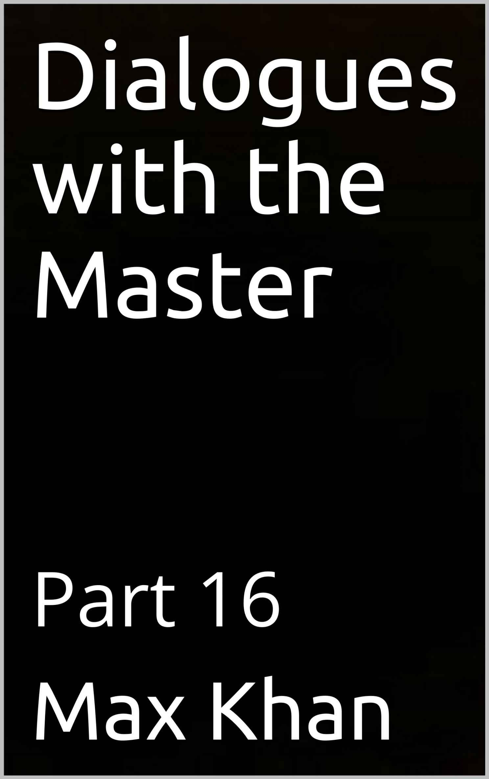

DIALOGUES WITH THE MASTER PART 16
MAX KHAN

STUDENT: MASTER, MY POOREST FRIENDS ARE THE MOST GENEROUS, AND MY WEALTHIEST FRIENDS ARE THE LEAST GENEROUS. HOW IS THAT POSSIBLE?
MASTER: GENEROSITY IS NOT A MATTER OF WEALTH. IT IS A MATTER OF THE HEART.
STUDENT: I AM ALWAYS TOLD TO BE MORAL, MASTER. BUT I WOULD RATHER BE A STALIN THAN A KIND BUT UNIMPORTANT PERSON.
MASTER: A KIND PERSON IS AN IMPORTANT PERSON. AN EVIL PERSON IS NEGATIVELY IMPORTANT AND THEREFORE UNIMPORTANT.
STUDENT: I THINK I UNDERSTAND, MASTER.
MASTER: BETTER A SMALL KINDNESS THAN A GREAT EVIL.
STUDENT: THAT MAKES SENSE, MASTER. BUT I HAVE SO LITTLE. I HAVEN’T THE MEANS TO BE GENEROUS.
MASTER: YOU HAVE THE MEANS TO BE KIND. STUDENT: THAT IS TRUE.
MASTER: THEREFORE YOU HAVE THE MEANS TO BE GENEROUS STUDENT: YOUR REASONING IS COGENT, MASTER.
MASTER: AND IF YOU GIVE, YOU WILL RECEIVE.
STUDENT: GIVING HANDS ARE RECEIVING HANDS, AS THE SAYING GOES. MASTER: AND IT IS A GOOD SAYING, MY SON.
STUDENT: EVERYTHING YOU ARE SAYING IS TRUE, MASTER. I DO HAVE IT WITHIN ME TO BE KIND, NO MATTER HOW POOR I AM.
MASTER: A KIND PERSON IS NEVER POOR, MY SON.
STUDENT: YES MASTER, BUT THERE IS MORE TO LIFE THAN KINDNESS.
MASTER: YES THERE IS. THERE IS ALSO ACCOMPLISHMENT. AND ACCOMPLISHMENT IS NOT ABOUT KINDNESS.
STUDENT: WHAT IS IT ABOUT, MASTER?
MASTER: TWO THINGS, MY SON. ABILITY AND PERSEVERANCE. STUDENT: DO I HAVE ABILITY, MASTER?
MASTER: THE VERY FACT THAT YOU ARE PARTICIPATING IN THIS EXCHANGE MEANS THAT YOU HAVE INTELLIGENCE AND THEREFORE ABILITY.

STUDENT: OR AT LEAST THE ABILITY TO HAVE ABILITY,
MASTER: THAT IS A GOOD POINT. A GOOD DISTINCTION. VERY CLEVER, ACTUALLY. INTELLIGENCE IS NOT ABILITY. ABILITY IS DEPLOYED INTELLIGENCE. INTELLIGENCE IS, AS YOU SAID, THE ABILITY TO HAVE ABILITY.
STUDENT: BUT GIVEN THAT I HAVE INTELLIGENCE, I HAVE THE ABILITY TO READILY ACQUIRE ABILITY.
MASTER: CORRECT.
STUDENT: BUT THE ROAD AHEAD IS SO LONG. IF I START NOW, IT WILL BE SO LONG BEFORE I GET TO WHERE I WANT TO GO. AND I DON’T KNOW IF I HAVE IT IN ME.
MASTER: YOU HAVE NO CHOICE. STUDENT: I CAN GIVE UP.
MASTER: GIVING UP IS FAILING TO MAKE A CHOICE.
STUDENT: BUT I DON’T KNOW THAT I HAVE THE STAMINA TO MAKE IT TO MY DESTINATION.
MASTER: DO YOU HAVE YOUR HEALTH? STUDENT: YES.
MASTER: THEN YOU HAVE THE STAMINA. STUDENT: BUT WHY I AM A DRAGGING MY FEET?
MASTER: THERE IS A TIME TO ASK QUESTIONS, AND THERE IS A TIME TO DO. STUDENT: AND NOW IS THE TIME TO DO.
MASTER: YES. AND REMEMBER, MY SON. REST WILL NOT SHORTEN THE JOURNEY. ONLY PERSEVERING WILL.
STUDENT: THEN I MUST EMBARK.
MASTER: GOOD. WE WILL TALK TOMORROW, MY SON. AND YOU WILL APPRISE ME OF YOUR PROGRESS.

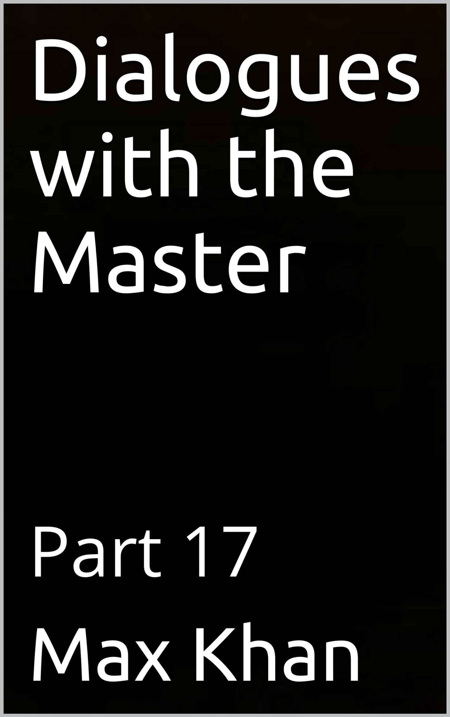

DIALOGUES WITH THE MASTER PART 17
MAX KHAN

MASTER: YOU DO NOT LOOK WELL, MY SON.
STUDENT: I INJURED MYSELF, MASTER. BUT I SIMPLY DON’T HAVE TIME TO GO TO THE DOCTOR.
MASTER: HE DOES NOT HAVE THE TIME TO HEAL DOES HAVE THE TIME TO DIE. STUDENT: NOT ONLY AM I INJURD. I AM OUT OF MONEY.
MASTER: WHY IS THAT, MY SON?
STUDENT: I ASKED MY LAWYER FOR ADVICE. I THOUGHT WE WERE OFF THE CLOCK. I THOUGHT HE WAS TALKING TO ME IN HIS CAPACITY AS FRIEND. THEN I GOT BILL FROM HIM.
MASTER: NEVER DRINK WATER IN THE HOUSE OF A MERCHANT. HE WILL CHARGE YOU FOR IT.
STUDENT: AND NOT ONLY AM I INJURED AND POOR. MY HOME LIFE IS UNHAPPY. MASTER: WHY IS THAT, MY SON?
STUDENT: I WORK ALL DAY TO PROVIDE FOR MY FAMILY AND TO BUY MY WIFE THE DIAMONDS AND FURS THAT SHE SO CRAVES. AND WHEN I TELL HER THAT I DON’T MONEY TO HAVE MY CAR FIXED OR TO GO DO THE DOCTOR, SHE TELLS ME THAT I AM BEING GREEDY.
MASTER: SHE WHO TELLS OTHERS TO BE HAPPY WITH WHAT THEY HAVE WANTS EVERYTHING FOR HERSELF.
STUDENT: I ALSO HAD TO GET A REPORT INTO MY BOSS. I SIMPLY DIDN’T FEEL LIKE DOING IT. SO I DIDN’T. I FIGURED THAT MY BOSS WOULD GIVE ME A BREAK. HE DIDN’T. HE DEMOTED ME.
MASTER: THE GRASSHOPPER WHO WORRIED NOT WHERE HE RESTED HIS HEAD WOKE UP IN THE LIZARD’S MOUTH.
STUDENT: I AM AT MY ROPE’S END, MASTER.
MASTER: IT IS UNDERSTANDABLE THAT YOU SHOULD FEEL THAT WAY. STUDENT: AND I HAVE NO IDEA WHAT TO DO. NONE.
MASTER: THAT IS ALL RIGHT, MY SON. WHAT IS NOT ALL RIGHT IS TO NOT DO ANYTHING.
STUDENT: HOW DO YOU MEAN, MASTER?
MASTER: BETTER TO WALK FOR NOTHING THAN TO REST FOR NOTHING.

STUDENT: THAT MAKES SENSE, MASTER. AFTER ALL, WHEN ONE RESTS, ONE GOES NOWHERE. AND WHEN ONE WALKS, ONE GOES SOMEWHERE.
MASTER: ALSO, WHEN ONE WALKS, EVEN IF ONE IS NOT WALKING ANYWHERE IN PARTICULAR, ONE DEVELOPS ONE’S ABILITY TO GO SOMEWHERE.
STUDENT: AND THE VERY FACT OF TRYING TO GO SOMEWHERE IS AFFIRMATION OF ONE’S DESIRE TO GO SOMEWHERE.
MASTER: AND THEREFORE OF ONE’S DESIRE TO KEEP ON LIVING. STUDENT: AND SOMETIMES THAT IS ENOUGH.
MASTER: THAT’S RIGHT, MY SON. AND IF ONE HANGS IN THERE DURING THE DARK TIMES, ONE FINDS THAT THEY DON’T LAST AND THAT THE WORLD BEYOND THE TUNNEL’S EXIT IS FAR BRIGHTER AND BETTER THAN THE WORLD BEFORE THE TUNNEL’S ENTRANCE.
STUDENT: GOOD WORDS, MASTER. GOOD WORDS, AND TRUE.
MASTER: THE TRUTH MAKES THE HEAVIEST BOULDER AS LIGHT AS A FEATHER.

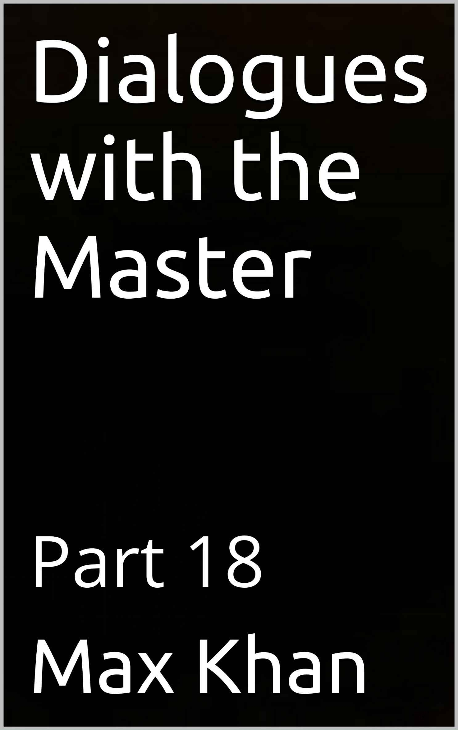

DIALOGUES WITH THE MASTER PART 18
MAX KHAN

STUDENT: I WORK HARD, MASTER. BUT NOT HARD ENOUGH TO PAY MY BILLS. MASTER: SO WORK HARDER, MY SON.
STUDENT: I AM AFRAID THAT IF I DO SO, I WILL DAMAGE MYSELF, EITHER PHYSICALLY OR EMOTIONALLY.
MASTER: A BACK DOES NOT BREAK FROM BENDING. STUDENT: HOW DO YOU MEAN, MASTER?
MASTER: YOU ARE BEING NEUROTIC, MY SON. YOU ARE NOT A DELICATE FLOWER. YOU ARE A MAN. AND MEN CAN WORK HARD. INDEED, IT IS STRENUOUS WORK THAT A MAN’S TRUE BLISS LIES.
STUDENT: THAT RINGS TRUE, MASTER. ALSO, IT OCCURS TO ME THAT IT ISN’T REALLY HARD WORK THAT I AM AFRAID OF.
MASTER: PLEASE ELABORATE.
STUDENT: I AM ACTUALLY AFRAID OF FAILING. I AM AFRAID THAT IF I WORK HARD, IT WILL ALL BE FOR NOUGHT, AS I SHALL FAIL TO ACHIEVE MY OBJECTIVE. AND MY SUPPOSED FEAR OF INJURING MYSELF THROUGH STRENUOUS LABOR WAS REALLY A DISPLACEMENT. A WAY OF DIVERTING MY ATTENTION AWAY FROM MY FEAR OF FAILING.
MASTER: THAT IS VERY INSIGHTFUL, MY SON.
STUDENT: BUT I HAVE MORE CONCERNS THAT I WOULD LIKE TO DISCUSS WITH YOU, MASTER.
MASTER: SPEAK.
STUDENT: AS YOU KNOW, I WRITE FOR A LIVING.
MASTER: YES, YOU ARE A VERY GOOD WRITER. A VERY PROLIFIC WRITER AND A VERY GOOD ONE. WITH A RICH AND DIVERSE, AND EVER-GROWING PORTFOLIO.
STUDENT: THANK YOU, MASTER. ANYWAY, I HAVE FOUND THAT HOW MUCH A GIVEN TITLE OF MINE SELLS IS NOT A FUNCTION OF HOW HARD I WORKED ON IT. I MAY WORK FOR 10 HOURS ON ONE TITLE FOR 20 MINUTES ON ANOTHER TITLE, AND THE SECOND IS AS LIKELY AS NOT TO OUTSELF THE FIRST.
MASTER: THAT MAKES SENSE.
STUDENT: HOW CAN THAT POSSIBLY MAKE SENSE? SURELY THE TITLE THAT I SPENT 10 HOURS WORKING ON IS BETTER THAN THE ONE I SPENT 20 MINUTES ON.

MASTER: NOT NECESSARILY. THE 20 MINUTE ONE MIGHT HAVE A SPONTANEITY AND A LIGHTNESS OF TOUCH THAT THE OTHER ONE LACKS.
STUDENT: THAT IS ACTUALLY CONSISTENT WITH WHAT SOME REVIEWERS HAVE WRITTEN.
MASTER: WHAT DID THEY SAY?
STUDENT: THEY DESCRIBED THE 10-HOUR ONE AS ‘LABORED’ AND ‘TORTURED’, AND THEY DESCRIBED THE 20-MINUTE ONE AS ‘HAVING A DELICIOUSLY LIGHT TOUCH’ AND ‘LIKE A PLEASANT SUMMER’S BREEZE.’
MASTER: THERE YOU GO.
STUDENT: SO WHAT AM TO CONCLUDE FROM THIS, MASTER? MASTER: THAT IT IS HARD TO MAKE THINGS EASY.
STUDENT: VERY PITHY, MASTER. VERY CONCISE, AS ALWAYS.
MASTER: THANK YOU, MY SON. I LOOK FORWARD TO OUR TALK TOMORROW.



DIALOGUES WITH THE MASTER PART 18
MAX KHAN

STUDENT: I WORK HARD, MASTER. BUT NOT HARD ENOUGH TO PAY MY BILLS. MASTER: SO WORK HARDER, MY SON.
STUDENT: I AM AFRAID THAT IF I DO SO, I WILL DAMAGE MYSELF, EITHER PHYSICALLY OR EMOTIONALLY.
MASTER: A BACK DOES NOT BREAK FROM BENDING. STUDENT: HOW DO YOU MEAN, MASTER?
MASTER: YOU ARE BEING NEUROTIC, MY SON. YOU ARE NOT A DELICATE FLOWER. YOU ARE A MAN. AND MEN CAN WORK HARD. INDEED, IT IS STRENUOUS WORK THAT A MAN’S TRUE BLISS LIES.
STUDENT: THAT RINGS TRUE, MASTER. ALSO, IT OCCURS TO ME THAT IT ISN’T REALLY HARD WORK THAT I AM AFRAID OF.
MASTER: PLEASE ELABORATE.
STUDENT: I AM ACTUALLY AFRAID OF FAILING. I AM AFRAID THAT IF I WORK HARD, IT WILL ALL BE FOR NOUGHT, AS I SHALL FAIL TO ACHIEVE MY OBJECTIVE. AND MY SUPPOSED FEAR OF INJURING MYSELF THROUGH STRENUOUS LABOR WAS REALLY A DISPLACEMENT. A WAY OF DIVERTING MY ATTENTION AWAY FROM MY FEAR OF FAILING.
MASTER: THAT IS VERY INSIGHTFUL, MY SON.
STUDENT: BUT I HAVE MORE CONCERNS THAT I WOULD LIKE TO DISCUSS WITH YOU, MASTER.
MASTER: SPEAK.
STUDENT: AS YOU KNOW, I WRITE FOR A LIVING.
MASTER: YES, YOU ARE A VERY GOOD WRITER. A VERY PROLIFIC WRITER AND A VERY GOOD ONE. WITH A RICH AND DIVERSE, AND EVER-GROWING PORTFOLIO.
STUDENT: THANK YOU, MASTER. ANYWAY, I HAVE FOUND THAT HOW MUCH A GIVEN TITLE OF MINE SELLS IS NOT A FUNCTION OF HOW HARD I WORKED ON IT. I MAY WORK FOR 10 HOURS ON ONE TITLE FOR 20 MINUTES ON ANOTHER TITLE, AND THE SECOND IS AS LIKELY AS NOT TO OUTSELF THE FIRST.
MASTER: THAT MAKES SENSE.
STUDENT: HOW CAN THAT POSSIBLY MAKE SENSE? SURELY THE TITLE THAT I SPENT 10 HOURS WORKING ON IS BETTER THAN THE ONE I SPENT 20 MINUTES ON.

MASTER: NOT NECESSARILY. THE 20 MINUTE ONE MIGHT HAVE A SPONTANEITY AND A LIGHTNESS OF TOUCH THAT THE OTHER ONE LACKS.
STUDENT: THAT IS ACTUALLY CONSISTENT WITH WHAT SOME REVIEWERS HAVE WRITTEN.
MASTER: WHAT DID THEY SAY?
STUDENT: THEY DESCRIBED THE 10-HOUR ONE AS ‘LABORED’ AND ‘TORTURED’, AND THEY DESCRIBED THE 20-MINUTE ONE AS ‘HAVING A DELICIOUSLY LIGHT TOUCH’ AND ‘LIKE A PLEASANT SUMMER’S BREEZE.’
MASTER: THERE YOU GO.
STUDENT: SO WHAT AM TO CONCLUDE FROM THIS, MASTER? MASTER: THAT IT IS HARD TO MAKE THINGS EASY.
STUDENT: VERY PITHY, MASTER. VERY CONCISE, AS ALWAYS.
MASTER: THANK YOU, MY SON. I LOOK FORWARD TO OUR TALK TOMORROW.

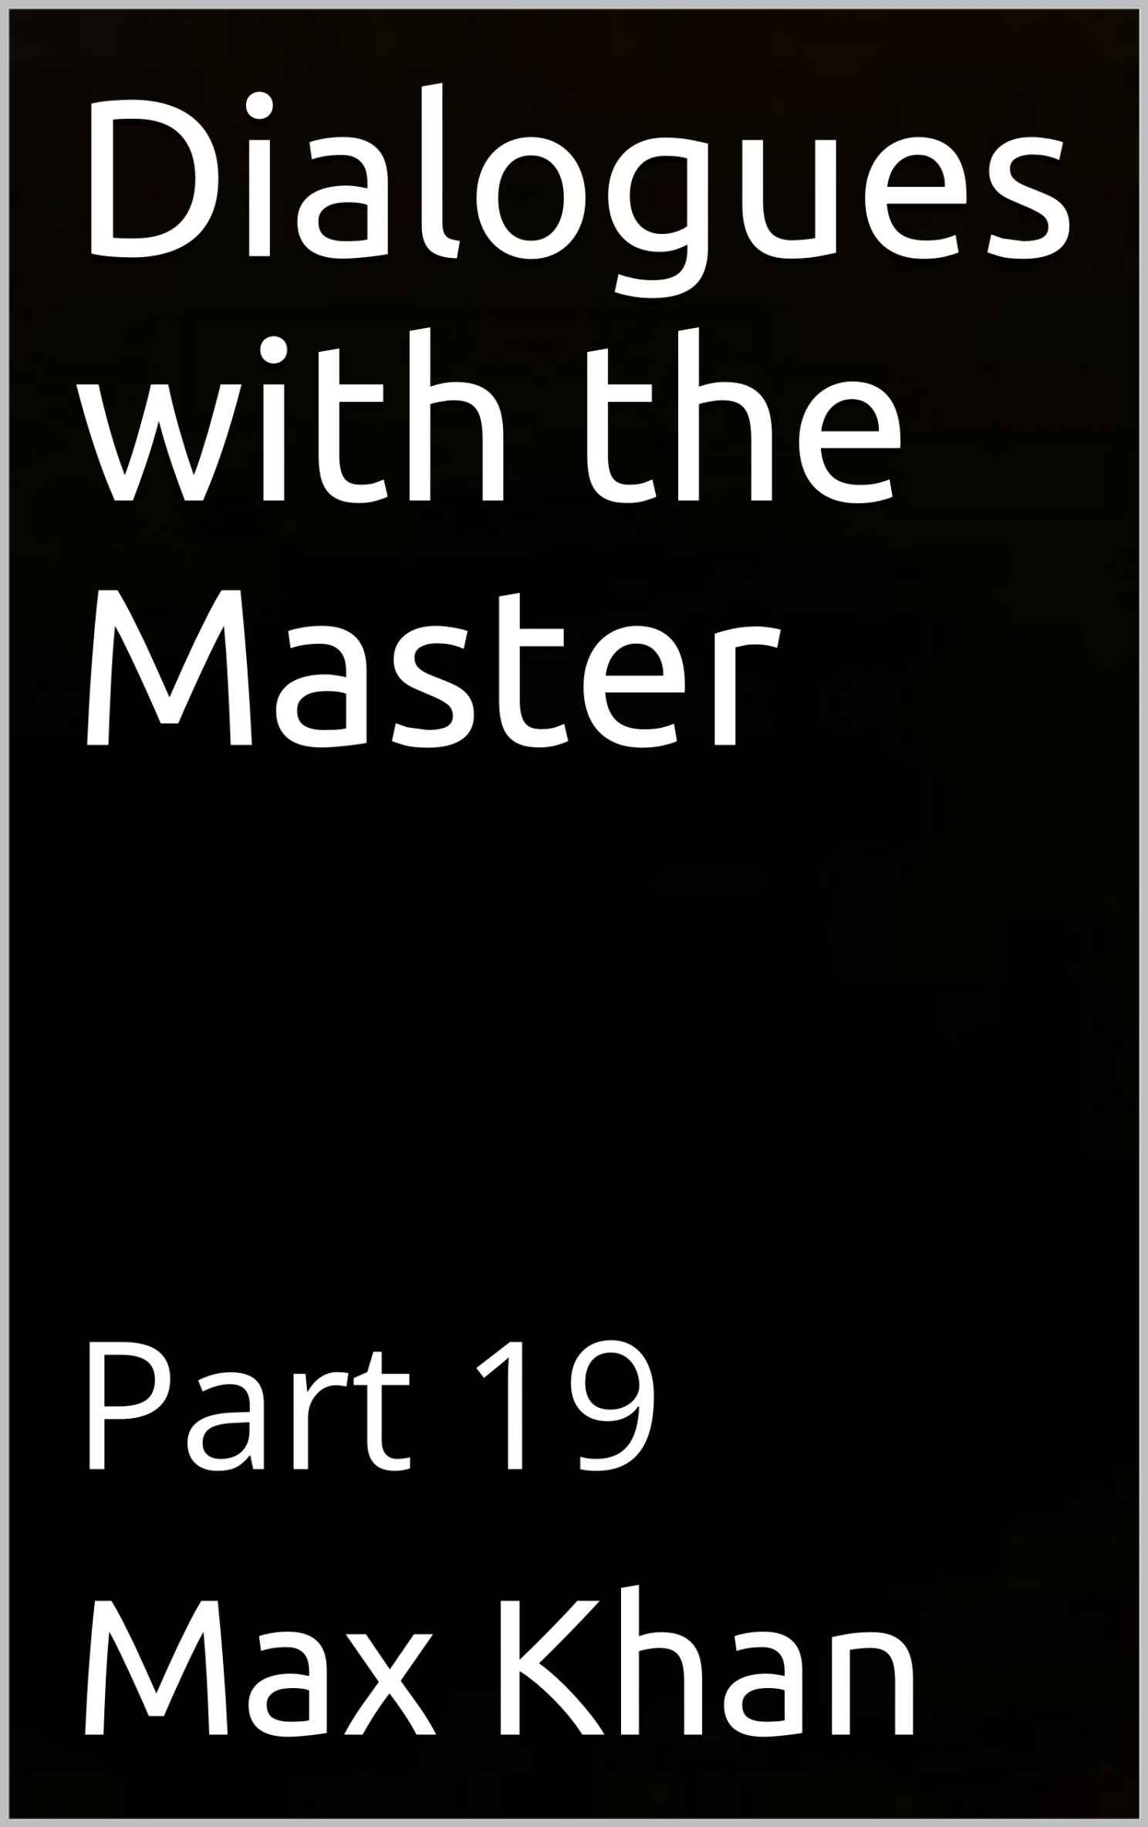

DIALOGUES WITH THE MASTER PART 19
MAX KHAN

MASTER: WHY LONG FACE TODAY, MY SON?
STUDENT: A BUSINESS VENTURE OF MINE DIDN’T WORK OUT. MASTER: WHAT ARE YOU DOING ABOUT IT?
STUDENT: NOTHING. OTHER THAN COMPLAINING TO ANYONE WHO WILL LISTEN.
MASTER: A BLEETING SHIP MISSES A BITE. STUDENT: MEANING?
MASTER: TIME SPENT COMPLAINING IS TIME THAT COULD BE SPENT ACCOMPLISHING.
STUDENT: POINT TAKEN.
MASTER: WHAT ELSE IS WEIGHING UPON YOU? STUDENT: I WAS DUMPED BY MY GIRLFRIEND. MASTER: SHE MUST HAVE BEEN BEAUTIFUL. STUDENT: SHE WAS. HOW DID YOU KNOW?
MASTER: A BEAUTIFUL ONE HURTS THE HURT. YOU ARE HURT. THEREFORE, SHE WAS BEAUTIFUL.
STUDENT: SHE WAS BEAUTIFUL, BUT SHE WAS EVIL. AND ODDLY INSECURE. ACTUALLY, SHE HAD MANY FLAWS.
MASTER: NOTHING BEAUTIFUL IS EVER PERFECT.
STUDENT: SO HER EXTERNAL BEAUTY MASKED INTERNAL DISFIGUREMENTS? MASTER: YES.
STUDENT: WAS THAT AN ACCIDENT OR WAS IT DELIBERATE?
MASTER: IT WAS DELIBERATE. EVEN THE MOST BEAUTIFUL WOMAN HAS TO WORK ON HER BEAUTY. FEMALE BEAUTY IS HIGH-MAINTENANCE. SHE OBVIOUSLY MAINTAINED IT. AND SHE DID SO BECAUSE SHE KNOW HOW IMPERFECT SHE WAS ON THE INSIDE.
STUDENT: VERY INSIGHTFUL, MASTER. THIS CONVERSATION IS MAKING ME FEEL BETTER.
MASTER: BUT YOU STILL AGGRIEVED.
STUDENT: IN THE LAST WEEK I HAVE EXPERIENCED SEVERAL SETBACKS. I ALREADY MENTIONED TWO. WHAT I DIDN’T MENTION IS THAT, AFTER EACH OF

THESE SETBACKS, I HASTILY TRIED TO FIX THE SITUATION, EVEN THOUGH I DIDN’T HAVE ANY DEFINITE PLAN.
MASTER: AND WHAT WAS THE RESULT?
STUDENT: THAT I MADE A BAD BUT FIXABLE SITUATION UNFIXABLE. MASTER: A BELT TIGHTENED WHILE RUNNING COMES UNFASTED. STUDENT: IN OTHER WORDS, WHAT IS DONE HASTILY DOESN’T HOLD. MASTER: PRECISELY, MY SON.
STUDENT: GOOD WORDS, MASTER. SEE YOU TOMORROW.

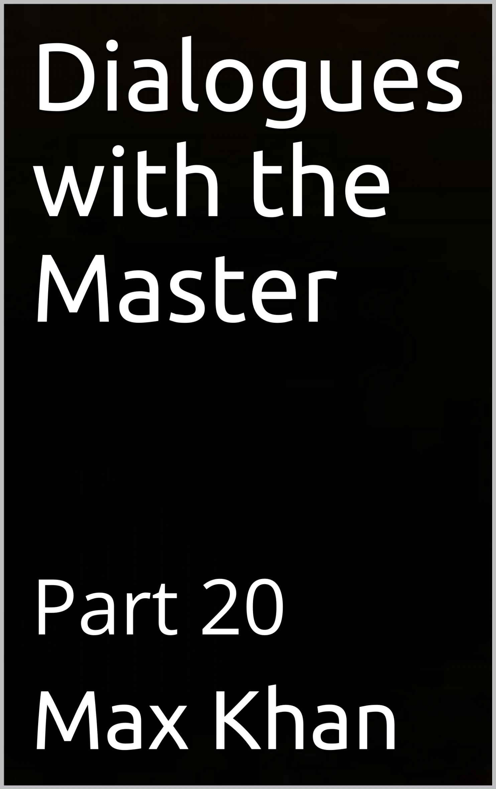

DIALOGUES WITH THE MASTER PART 20
MAX KHAN

MASTER: YOU ARE GRINNING EAR TO EAR, MY SON. WHY ARE YOU SO HAPPY?
STUDENT: A PERSON WHO DID ME A VERY BAD TURN WAS HIMSELF DONE A VERY BAD TURN.
MASTER: A BAD COOK HAS HIS SHARE OF BAD FOOD.
STUDENT: IN OTHER WORDS, WHAT GOES AROUND COMES AROUND.
MASTER: THAT’S RIGHT. BUT I SENSE A CERTAIN SADNESS UNDERNEATH YOUR EBULLIENCE.
STUDENT: YOU ARE VERY PERCEPTIVE, MASTER. MASTER: WHAT HAPPENED?
STUDENT: I HAD TO CHOOSE BETWEEN TWO DIFFERENT PROJECTS. I COULDN’T MAKE UP MY MIND AND DID EACH HALF-HEARTEDLY. AND I FAILED UTTERLY AT EACH.
MASTER: A BIRD HANGING BETWEEN TWO BRANCHES WILL GET BITTEN ON BOTH WINGS.
STUDENT: ALSO, I WAS USING MY FRIEND’S CAR. AND HE STOPPED LETTING ME USE IT.
MASTER: A BORROWED COAT DOESN’T KEEP ONE WARM. STUDENT: ALL IN ALL IT HAS NOT BEEN A GOOD WEEK. MASTER: IS THAT TRUE?
STUDENT: HOW DO YOU MEAN, MASTER?
MASTER: I SENSE THAT THERE IS GOOD NEWS THAT YOU ARE NOT DISCLOSING. STUDENT: AS YOU KNOW, I WAS DUMPED LAST WEEK.
MASTER: YES YOU TOLD ME.
STUDENT: ANWAY, I MET SOMEONE ELSE.
MASTER: THAT’S GREAT! WHY IS THIS THE FIRST I’M HEARING OF IT? STUDENT: BECAUSE I’M EMBARRASSED ABOUT THE SITUATION?
MASTER: WHY ON EARTH ARE YOU EMBARRASSED ABOUT IT?
STUDENT: BECAUSE THE BASIS OF OUR RELATIONSHIP IS THAT WE BOTH OF HAVE OCD.
MASTER: SO YOU UNDERSTAND EACH OTHER’S VULNERABILITIES.

STUDENT: EXACTLY.
MASTER: THAT’S NO REASON TO BE EMBARRASSED, MY SON. STUDENT: IT ISN’T?
MASTER: NOT AT ALL. ALL VIABLE RELATIONSHIPS ARE BASED, AT LEAST IN PART, ON SHARED VULNERABILITIES.
STUDENT: THAT MAKES SENSE. A CAMEL DOES NOT TEASE ANOTHER CAMEL ABOUT ITS HUMPS.
MASTER: EXACTLY. AND THAT STATEMENT IS APPROPRIATE ON TWO LEVELS. STUDENT: HOW DO YOU MEAN, MASTER?
MASTER: A CAMEL’S HUMP IS LIKELY TO BE A SOURE OF RIDICULE TO A NON- CAMEL, BECAUSE A NON-CAMEL SEES A CAMEL’S HUMP AS A USELESS GROWTH. BUT IN ACTUALITY A CAMEL’S HUMP STORES WATER AND THEREFORE ENABLES IT TO DESERVE WHERE OTHER CREATURES PERISH FOR LACK OF WATER.
STUDENT: YOUR POINT BEING THAT OCD, AND PECULIARITIES OF CHARACTER GENERALLY, EMBODY STRENGTHS OF INTELLECT AND CHARACTER AND THEREFORE ARE NOT, AT LEAST NOT MERELY, PATHOLOGIES.
MASTER: EXACTLY, MY SON. EXACTLY.
STUDENT: SO THE ‘SHARED VULNERABILITIES’ ON WHICH RELATIONSHIPS ARE BASED ARE ACTUALLY SHARED STRENGTHS?
MASTER: EXACTLY, MY SON.
STUDENT: AND PERHAPS THOSE CHARACTERISTICS OF OURS THAT WE REGARD AS OUR VULNERABILITIES ARE OFTENTIMES ACTUALLY STRENGTHS.
MASTER: THAT IS AN EXCELLENT POINT, MY SON, WHOSE DEPTHS WE WILL PLUMB IN LATER EXCHANGES.
STUDENT: I LOOK FORWARD TO IT, MASTER.

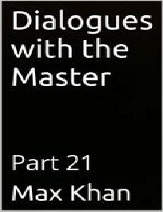

DIALOGUES WITH THE MASTER PART 21
MAX KHAN

MASTER: WHY THE LONG FACE, MY SON?
STUDENT: MASTER, AS YOU KNOW, I WAS A PROFESSOR.
MASTER: YES. YOU WERE BRILLIANT. BUT YOU RIGHTLY DISAGREED WITH THE PRACTICES OF THIS COUNTRY’S UTTERLY BROKEN EDUCATIONAL ESTABLISHMENT AND THUS RESIGNED OUT OF PRINCIPLE.
STUDENT: YES, THAT IS WHAT HAPPENED. BUT THERE WAS AN UPSIDE TO BEING A PROFESSOR.
MASTER: AND WHAT WAS THAT?
STUDENT: THE MONEY. THEY SAY THAT PROFESSORS DON’T MAKE A LOT OF MONEY. BUT THEY DO. RELATIVE TO THE AMOUNT OF WORK THEY DO, THEY MAKE AN ENORMOUS AMOUNT OF MONEY.
MASTER: YES, RELATIVE TO THE WORK THEY DO, WHICH IS NONE, THEY MAKE AN INFINITE AMOUNT.
STUDENT: YES, AND IN ABSOLUTE TERMS, THEY MAKE A PRETTY DECENT AMOUNT.
MASTER: AND HOW DOES THIS RELATE TO YOUR CURRENT EMOTIONAL PREDICAMENT?
STUDENT: WHEN I QUIT MY ACADEMIC POST, I HAD A LOT OF MONEY SAVED UP FROM YEARS AS A PROFESSOR. THEN I WENT INTO BUSINESS FOR MYSELF. AND, AS YOU KNOW, MY FIRST FEW VENTURES FAILED UTTERLY, AND I LOST ALL MONEY.
MASTER: YES. YOU’VE TOLD ME THIS.
STUDENT: IN ANY CASE, HAD I BEEN EVEN SLIGHTLY MORE INTELLIGENT WITH ALL OF MY PROFESSOR MONEY, I WOULD BE A RICH MAN NOW. BUT I FOOLISHLY SQUANDERED IT.
MASTER: SO YOUR POSITION IS THAT IT WAS IGNORANCE, OR FOOLISHNESS, OR SOME SUCH THAT LED TO YOU LOSE THAT MONEY.
STUDENT: YES.
MASTER: I DON’T THINK THAT’S WHAT WAS GOING ON. STUDENT: HOW DO YOU MEAN, MASTER?
MASTER: YOU RESIGNED YOUR ACADEMIC POST BECAUSE YOU SAW THAT THE ACADEMY IS A FRAUD. IS THAT RIGHT?
STUDENT: YES.
MASTER: AND YOU SAW THAT PROFESSORS ARE FRAUDSTERS? STUDENT: YES.

MASTER: AND THAT THEIR GAINS ARE ALL ILL-GOTTEN. STUDENT: YES.
MASTER: DO YOU SEE WHERE I AM GOING? STUDENT: NO.
MASTER: EVIL GOTTEN, QUICKLY SPENT. STUDENT: PLEASE CLARIFY, MASTER.
MASTER: MONEY THAT ISN’T EARNED IS QUICKLY WASTED. AND IT’S WASTED PRECISELY BECAUSE IT’S CHEAP AND EMPTY, AND ITS POSSESSOR WANTS NOTHING TO DO WITH IT.
STUDENT: I SEE. SO IT’S NOT THAT I DIDN’T UNDERSTAND MONEY. IT’S THAT I DID UNDERSTAND IT. AND I SAW THAT THE MONEY I HAD WAS DIRTY, AND I WANTED NOTHING TO DO WITH IT.
MASTER: SO YOU GAVE IT AWAY. YOU TOLD YOURSELF THAT YOU WERE SPENDING IT LAVISHINGLY. BUT YOU WERE REALLY JUST GETTING RID OF IT.
STUDENT: SO THAT I COULD START WITH A CLEAN SLATE. MASTER: THAT’S RIGHT.
STUDENT: SO I SHOULD BE PROUD OF MYSELF, FOR MY INTEGRITY.
MASTER: YES, YOU SHOULD. BE GLAD THAT NOTHING IS TYING TO THAT UGLY AND CORRUPT WORLD. YOU ARE FREE.
STUDENT: THANK YOU, MASTER. THIS HAS BEEN HELPFUL.

